1. **Design**

To solve the Music Data Analysis Requirement the following modules are used

1. **LoadHBaseTables –** This is used for loading the lookup data from csv files to the relevant tables in Hbase. Hbase tables used are as below:

* **StationIdGeoCd –**  This HBase table is used for storing mapping between stationId and GeoCd
* **SongArtist -** This HBase table is used for storing mapping beween Song and Artist
* **UserArtist –** This HBase table is used for storing mapping beween userId and List of artists he follows
* **UserSubscription-** This HBase table is used for storing mapping beween userId and subscription start timestamp and end timestamp

1. **MusicDataProcessorApp -** This is the main application for processing music data. It in turn calls multiple submodules as below
2. **WebMusicDataProcessor –** This is the class for processing music data stored in /data/web/file-1.xml folder and use processData method to return dataframes
3. **MobileMusicDataProcessor -** This is the class for processing music data stored in /data/mob/file.txt folder and use processData method to return dataframes
4. **MusicDataEnricher -** This is the used for enriching and validating the datasets. New columns are added to dataframe for the processed data. The new columns added to temporary table MusicDataDetailed are as below:

**a.** modified_Geo_cd **–** This field is used to populate Null/blank values in Geo_cd column. If Geo_cd column is not blank, the value will copied as it is to modified_Geo_cd. If Geo_cd column is blank then consults the look table StationIdGeoCd based on stationId, If found populate it, else put value Invalid

**b.** modified_Artist_id **–** This field is used to populate Null/blank values in Artist_id column. If Artist_id column is not blank, the value will copied as it is to modified_Artist_id. If Artist_id column is blank then consults the look table SongArtist table based on songId, If found populate it, else put value Invalid

c. follower – This field is used when the user follows the artist. For each record, for userId consult UserArtist table to find the list of artists user is following. If it is blank, then follower will be 0. If it is not blank and the corresponding artistId for the record is present in artist List from the map, then set follower to 1

d. subscribed – This filed is used to know if the user was a subscriber when he played the music. This is done by getting the userId for the record and consulting **UserSubscription** table to get the tuple (start_ts,end_ts). If it does not exist then subscribed field will be 0. If I exists, If the start_ts of record is in between (start_ts,end_ts) of UserSubscritpion then subscribed field will be 1 else it will be 0

e. isValid- This field is used to know if the record is valid or not. Isvalid if valid will have value 1 else 0. The following validations are done:

If User_id is blank then (0)

If Song_id is blank then 0

If modified_Geo_cd is Invalid then 0

If modified_Arist_id is Invalid then 0

If timestamp is 0 then 0

If Start_ts is 0 then 0

If Start_ts > End_ts then0

1. **MusicDataPopulateMapFromLookupTables -** This is the used for populating maps from HBase tables used for lookup
2. **MusicDataAnalyzer - -** This is used for analyzing the data in dataframes and store the results in HDFS file:

Top10Stations_<Timestamp> - Top 10 stations where maximum number of songs played which is liked by unique user

MusicDurationByUserType_<Timestmp> - Music Duration by user category of user: Subscribed, Unsubscribed

Top10SongsHavignMaximumRevenue_<Timestamp> - Top 10 songs having maximum revenue

Top10ConnectedArtists_<Timestamp> - Top 10 connected artists

Top10UnsubscribedUsers_<Timestamp> - Top 10 unsubscribed users

1. **Implementation**

**MODULE1: LoadHBaseTables: Loading HBase Tables with Lookup Data**

Step1: Start all the services

Start the services using start-all.sh

Start HBase using:

start-hbase.sh

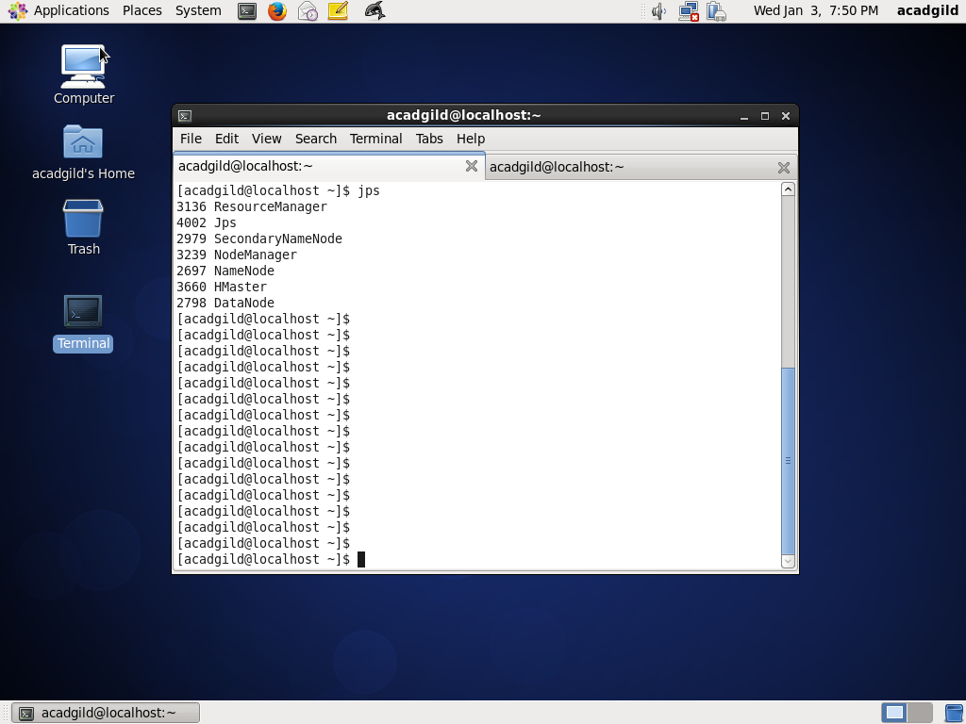

Confirm that services are up using command: jps



Step2: Create class for loading Hbase tables

Create a project load-hbase-tables and create a scala class LoadHBaseTables which is explained below:

* Import all the dependent packages and create the package

package final_project

import org.apache.log4j.{Level, LogManager, PropertyConfigurator}

import org.apache.spark._

import org.apache.spark.sql.SQLContext

import org.apache.hadoop.hbase.util.Bytes

import org.apache.hadoop.hbase.client.{ Put, HTable }

import org.apache.hadoop.hbase.HBaseConfiguration

import org.apache.hadoop.hbase.HTableDescriptor

import org.apache.hadoop.hbase.HColumnDescriptor

import org.apache.hadoop.hbase.client.HBaseAdmin

import org.apache.hadoop.hbase.client.HTable

import org.apache.spark.rdd.RDD

import org.apache.hadoop.hbase.mapreduce.TableInputFormat

import org.apache.log4j.{Level, LogManager, PropertyConfigurator}

* Create object LoadHBaseTables and define main method and logs

object LoadHBaseTables {

def main(args: Array[String]) {

val log = LogManager.getRootLogger

log.setLevel(Level.INFO)

* Get all the arguments, argument 1 is for filePath of lookup file, argument 2 is table name, argument 3 is composite fields of separated fields of Column Family and Column, which can be multiple

val filePath = args(0)

val tablename = args(1)

val columnFamilyField = args(2)

val columnFamilyFieldList = columnFamilyField.split(",")

val columnFamilyFieldListLength = columnFamilyFieldList.length

* Create configuration, Spark Context, SQL Context

val conf = new SparkConf().setAppName("LoadHbaseTable").setMaster("local[2]")

val sc = new SparkContext(conf)

sc.setLogLevel("ERROR")

val sqlContext = new SQLContext(sc)

* Create HBase configuration

val hconf = HBaseConfiguration.create

hconf.set(TableInputFormat.INPUT_TABLE, tablename)

val admin = new HBaseAdmin(hconf)

* Check if tables is already created or not . If not created, create table and its column family

if (!admin.isTableAvailable(tablename)) {

log.info("Creating table " + tablename)

val tableDescription = new HTableDescriptor(tablename)

tableDescription.addFamily(new HColumnDescriptor(columnFamilyFieldList(0).getBytes()))

admin.createTable(tableDescription)

if (admin.isTableAvailable(tablename)) {

log.info("Table " + tablename + " is created successfully")

}

} else {

log.warn("Table " + tablename + " already exists")

}

* Get the table and

val table = new HTable(hconf, tablename)

* Process the csv file which has lookup data and create tuples using map with key and value. If there are multiple fields given, value is taken as a tuple

val file = sc.textFile("file://" + filePath)

var records1:Array[(String,String)] = null

var records2:Array[(String,String,String)] = null

if (columnFamilyFieldListLength == 2) {

records1 = file.map(_.split(",")).map(x => (x(0), x(1))).collect

} else if (columnFamilyFieldListLength == 4) {

records2 = file.map(_.split(",")).map(x => (x(0), x(1), x(2))).collect

}

* Save the columns

if (columnFamilyFieldListLength == 2) {

for(record <- records1) {

var p = new Put(new String(record._1).getBytes())

p.add(columnFamilyFieldList(0).getBytes(), columnFamilyFieldList(1).getBytes(), new String(record._2).getBytes())

table.put(p)

}

} else if (columnFamilyFieldListLength == 4) {

for(record <- records2) {

var p = new Put(new String(record._1).getBytes())

p.add(columnFamilyFieldList(0).getBytes(), columnFamilyFieldList(1).getBytes(), new String(record._2).getBytes())

table.put(p)

var q = new Put(new String(record._1).getBytes())

q.add(columnFamilyFieldList(2).getBytes(), columnFamilyFieldList(3).getBytes(), new String(record._3).getBytes())

table.put(q)

}

}

table.flushCommits()

}

}

Screenshots are as below:

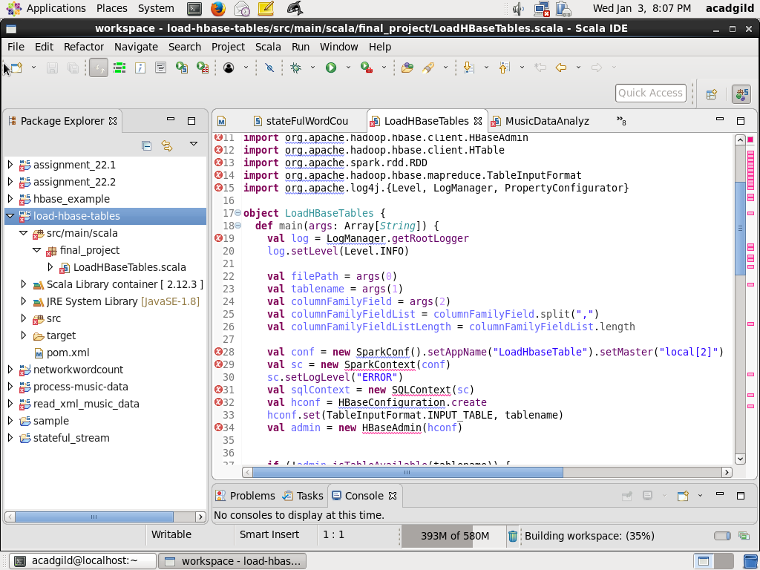

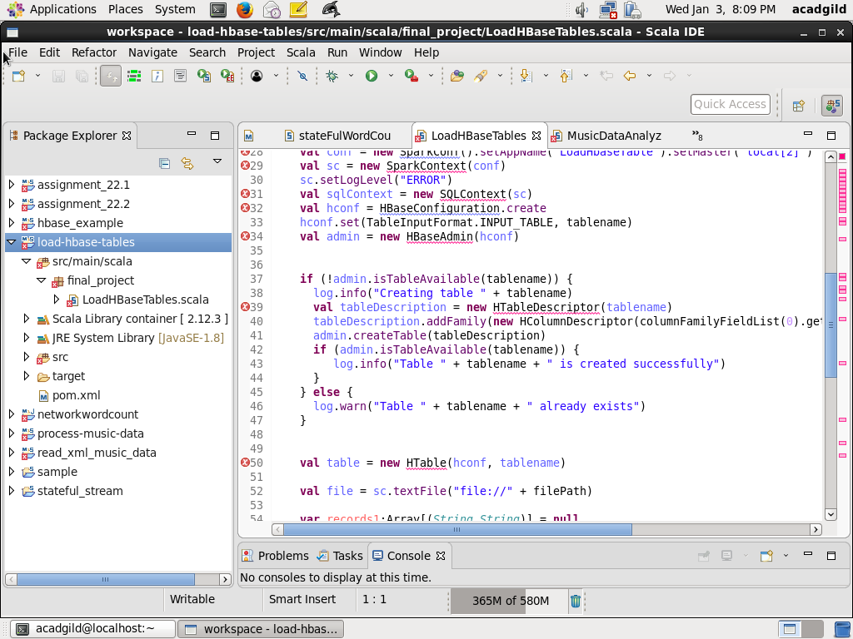

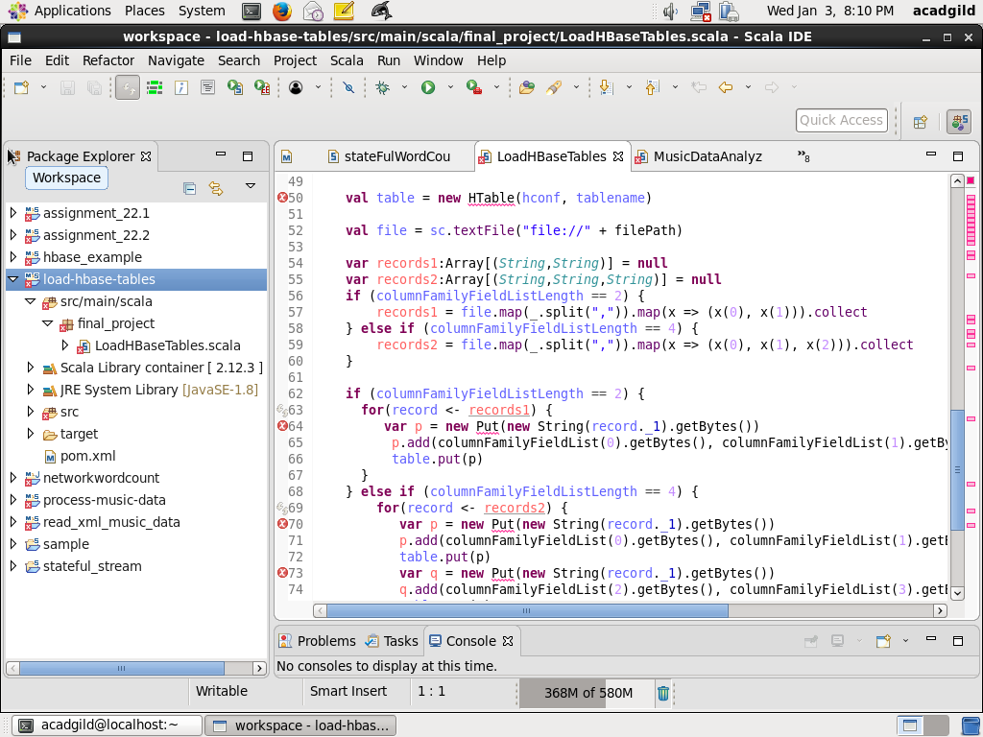

Step3: Compile the file using eclipse and run the code

* Define the pom file

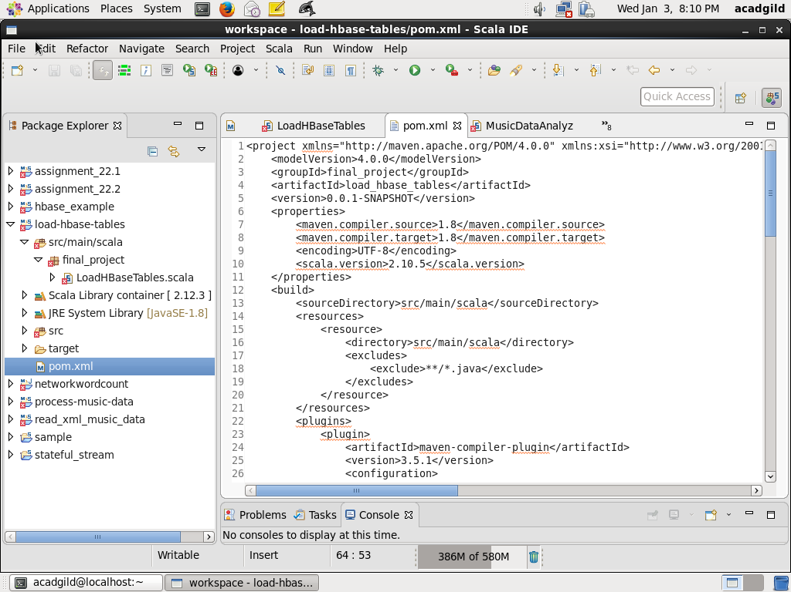

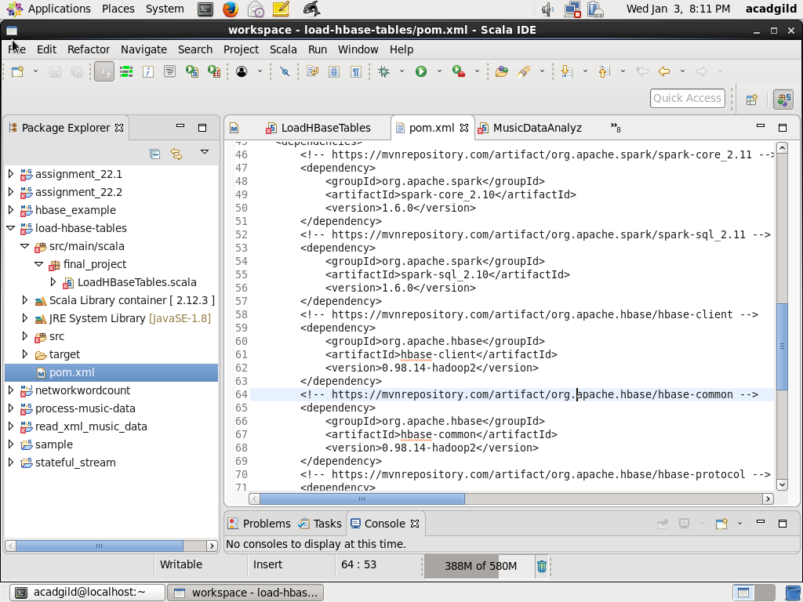

* Compile using maven install, screenshot is as below:

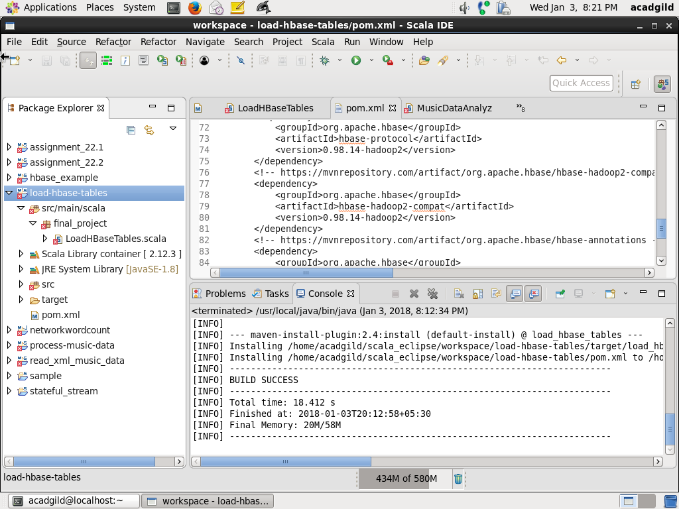

* Write a script to load all the tables:

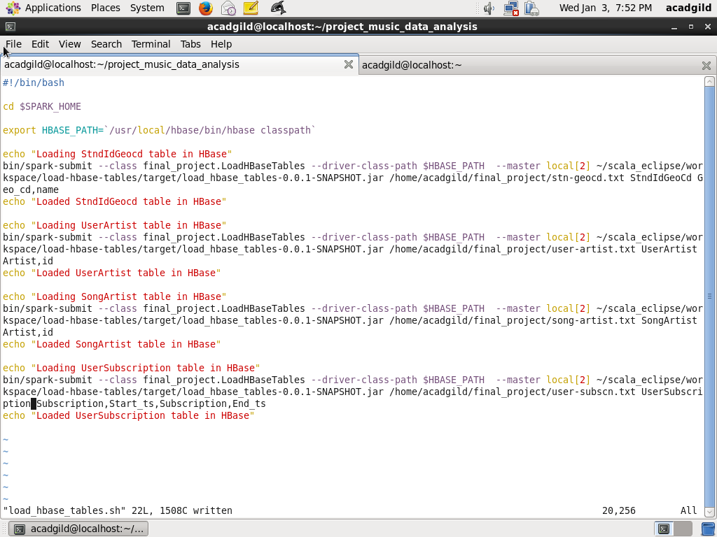

* Run the script to load all the tables

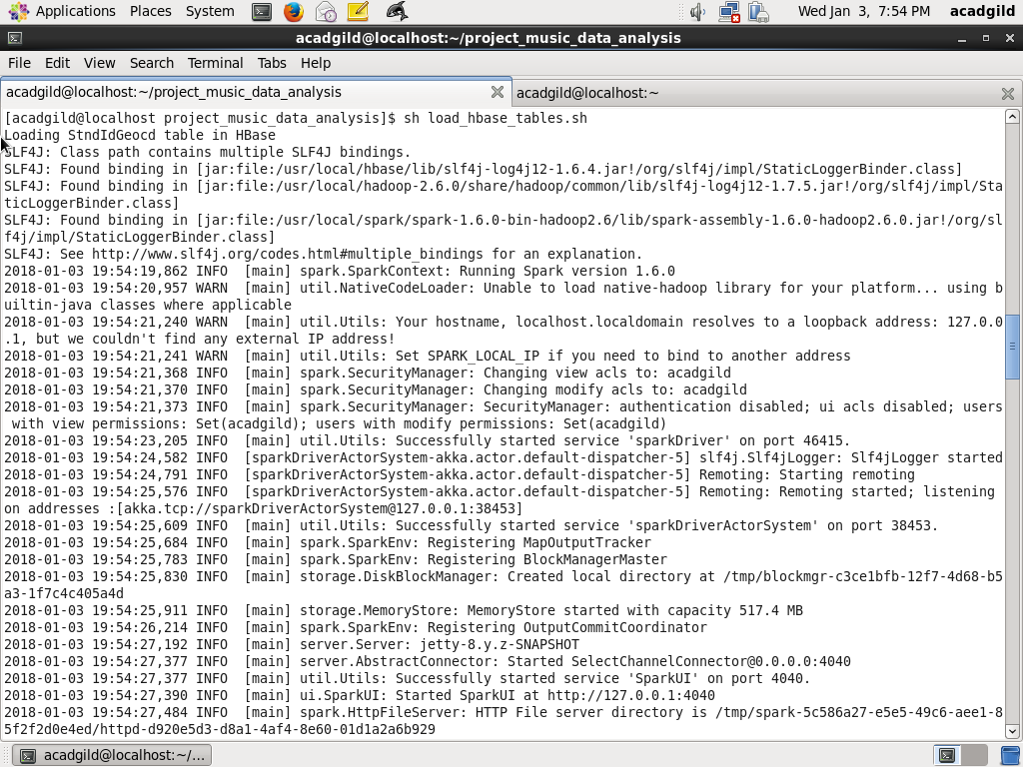

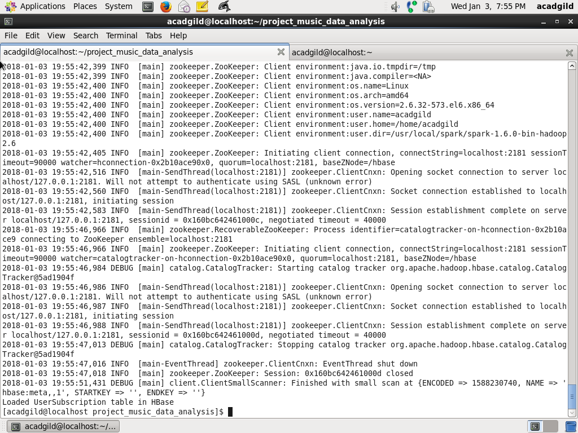

Step3: Verify that all the lookup tables are populated correctly

* Verify all the tables are populated correctly first login to HBase using

hbase shell

* Table StnIdGeoCd is verified using

scan ‘StnIdGeoCd’

Screenshot is as below:

* 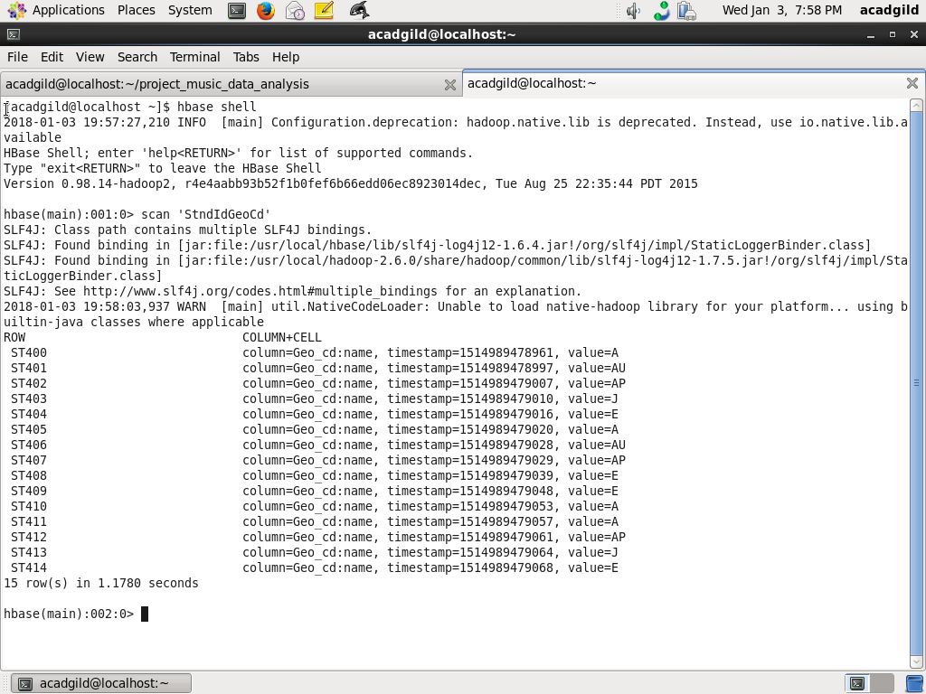
* Table UserArtist is verified using

scan ‘UserArtist’

Screenshot is as below

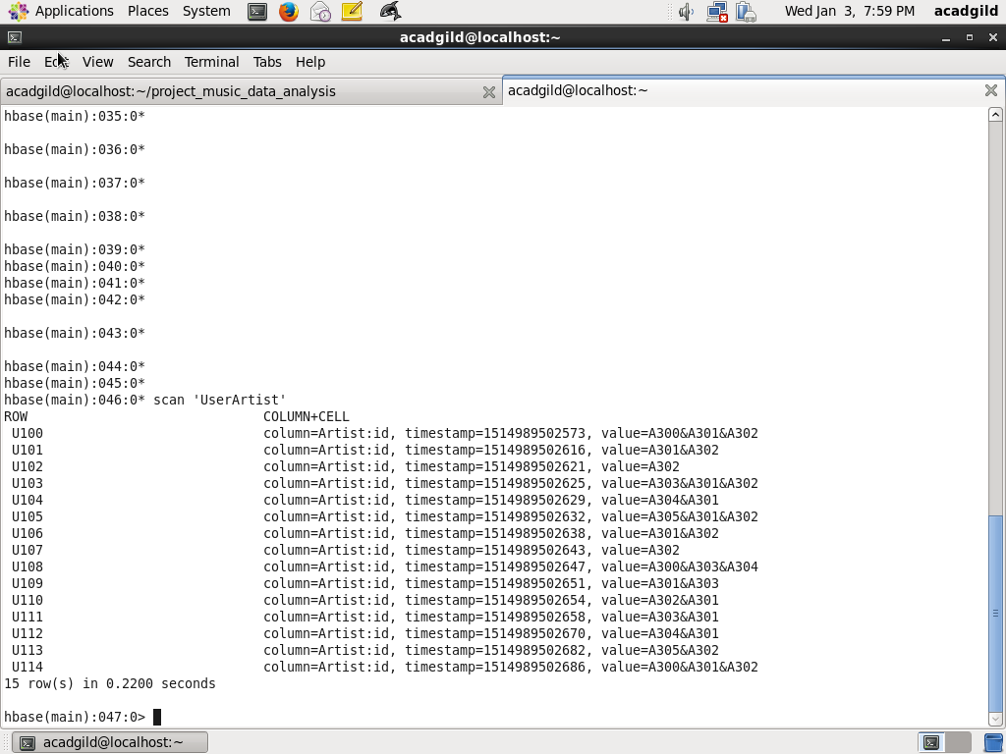

* Table SongArtist is verified using

scan ‘SongArtist’

Screenshot is as below:

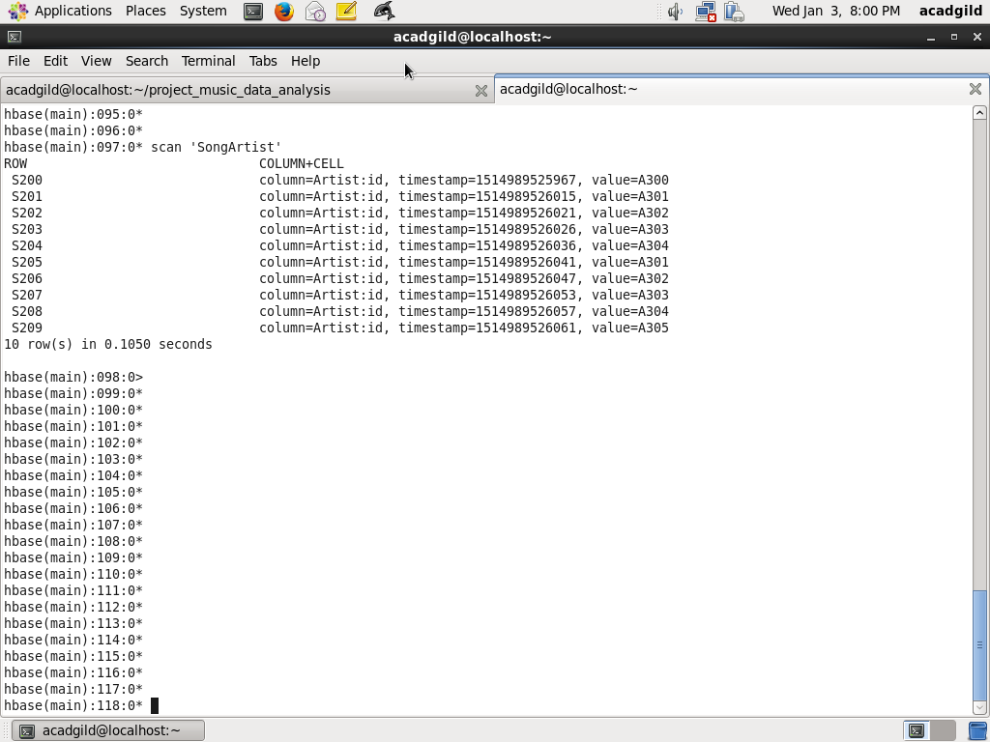

* Table UserSubscription is verified using

scan ‘UserSubscription’

Screenshot is as below:

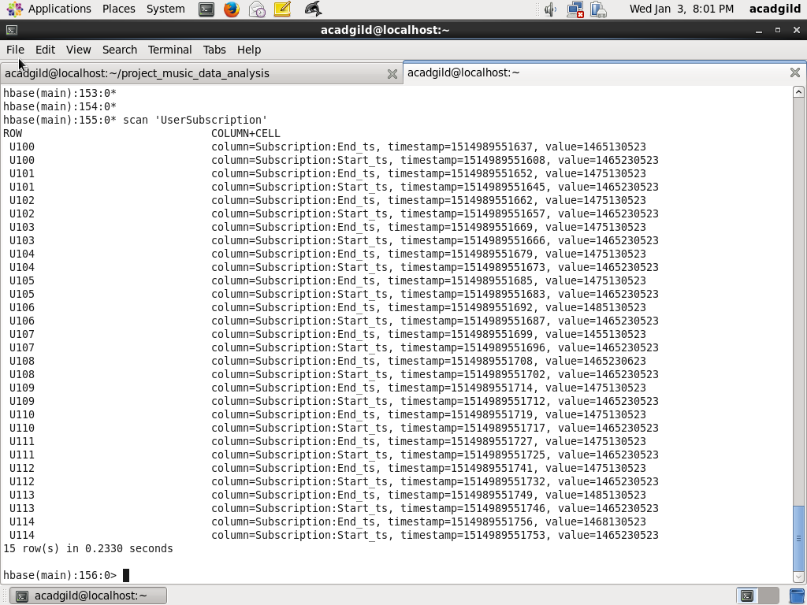

**MODULE2: Handling Web and Mobile Data**

Step1: Write a scala class for handling Web data

* Write class WebMusicDataProcessor to process web music data stored in /data/web/file-1.xml and store it as dataframe

-Import dependent packages

package final_project

import org.apache.spark._

import scala.xml.XML

import org.apache.spark.sql.DataFrame

import scala.collection.mutable.ListBuffer

import org.apache.spark.sql.SQLContext

import org.apache.spark.sql.types._

import org.apache.log4j.{ Level, LogManager, PropertyConfigurator }

import org.apache.spark.broadcast.Broadcast

import java.text.SimpleDateFormat

import scala.collection.mutable.HashMap

// Define CustomException this is to solve the continue

case class CustomException(message:String) extends Exception(message)

// Define the class with WebMusicDataProcessor with parametes

class WebMusicDataProcessor(param: String, context: SparkContext, sqc: SQLContext) extends Serializable {

val filePath: String = param

val sc: SparkContext = context

val sqlContext:SQLContext = sqc

// Define the method which does the processing of data and return as dataframe

def processData(): DataFrame = {

val log = LogManager.getRootLogger

log.setLevel(Level.INFO)

// val sqlContext = new SQLContext(sc)

import sqlContext.implicits._

// Define dateFormat as yyyy-MM-dd HH:mm:ss and recordListBuffer which will act as buffer for storing data

val dateFormat = new SimpleDateFormat("yyyy-MM-dd HH:mm:ss")

val recordListBuffer = new ListBuffer[(String, String, String, Long, Long, Long, String, String, String, String, String)]()

// Load data from XML path

val xml = XML.loadFile(filePath)

* Process all the fields user_id, song_id, artist_id, timestamp, start_ts,end_ts. Handle all null conditions

for (tag <- xml.child) {

val userId = (tag \ "user_id").text

val songId = (tag \ "song_id").text

var artistId = (tag \ "artist_id").text

val timestamp = (tag \ "timestamp").text

var timestampLong:Long = 0

if (!timestamp.equals("")) {

timestampLong = dateFormat.parse(timestamp).getTime()

}

val startTs = (tag \ "start_ts").text

var startTsLong:Long = 0

if (!startTs.equals("")) {

startTsLong = dateFormat.parse(startTs).getTime()

}

val endTs = (tag \ "end_ts").text

var endTsLong:Long = 0

if (!endTs.equals("")) {

endTsLong = dateFormat.parse(endTs).getTime()

}

var geoCd = (tag \ "geo_cd").text

val stationId = (tag \ "station_id").text

val songEndType = (tag \ "song_end_type").text

var like = (tag \ "like").text

if (like.equals("")) like = "0"

var dislike = (tag \ "dislike").text

if (dislike.equals("")) dislike = "0"

try {

// Continue with the record in case fileds are blank

if (userId.equals("") && songId.equals("") && artistId.equals("")) {

throw CustomException("Record is blank")

} else {

recordListBuffer += ((userId, songId, artistId, timestampLong, startTsLong, endTsLong, geoCd, stationId, songEndType, like, dislike))

}

} catch {

case CustomException(msg) => msg

}

}

// From the buffer convert to dataFrame recordDF having fields User_id, Songs_id, Artist_id, Timestamp, // Start_ts, End_ts, Geo_cd, Station_id, Song_end_type, Likes, Dislikes

val recordList = recordListBuffer.toList

val recordRDD = sc.parallelize(recordList)

val recordDF = recordRDD.toDF("User_id", "Songs_id", "Artist_id", "Timestamp",

"Start_ts", "End_ts", "Geo_cd", "Station_id", "Song_end_type",

"Likes", "Dislikes")

log.info("Number of records =" + recordDF.count)

log.info("Showing records for Web Music Data ")

recordDF.show

return recordDF

}

Screenshot is as below:

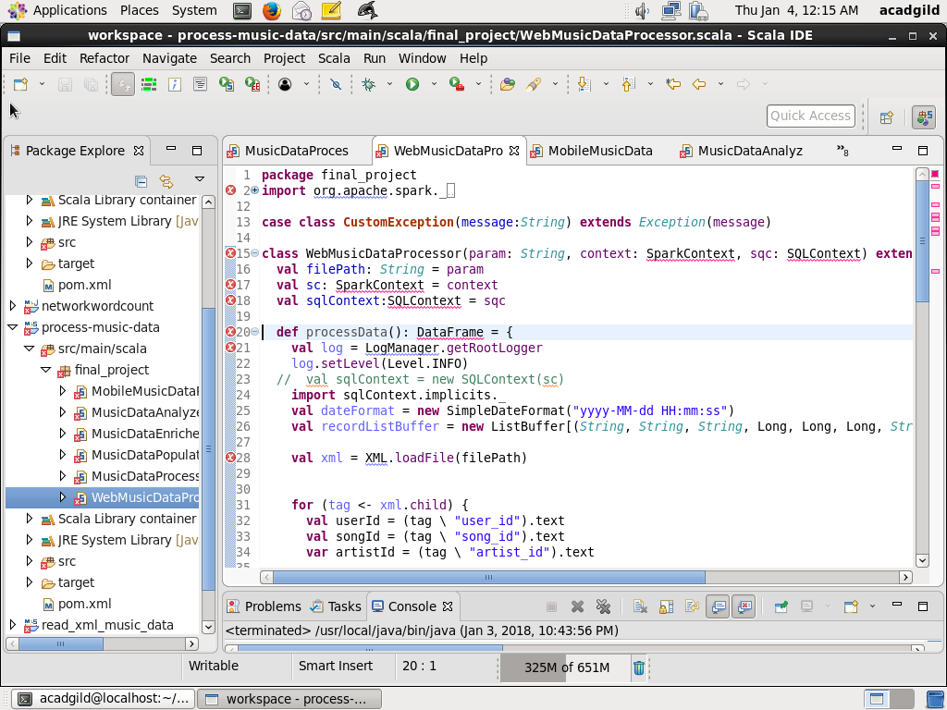

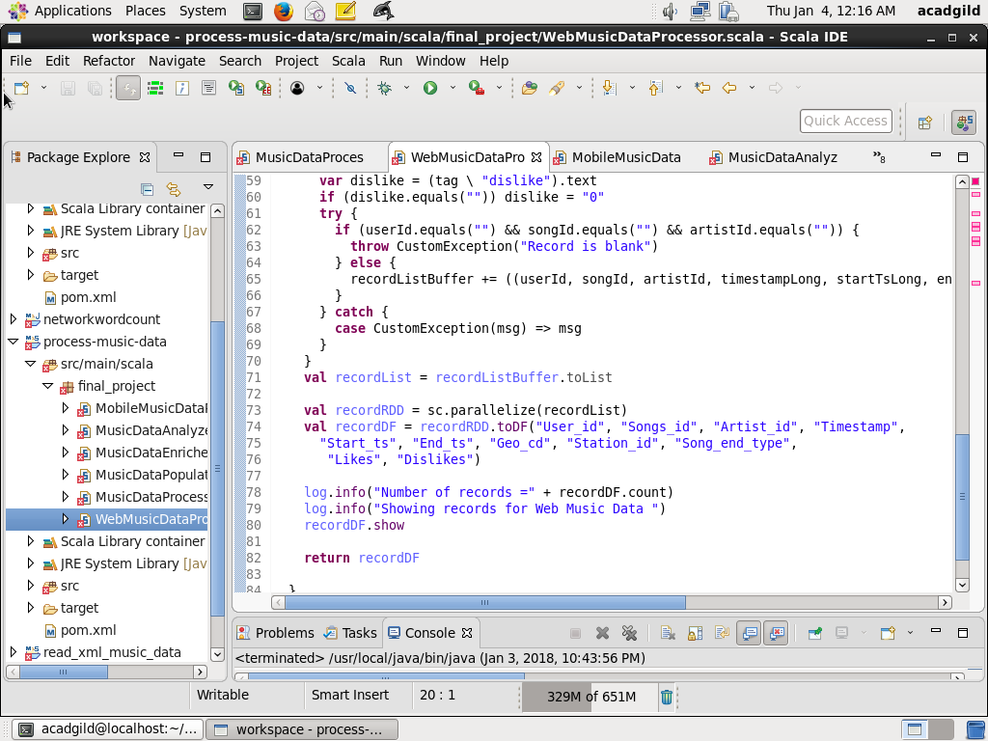

Step2: define class for processing Mobile data

* Define a class MobileMusicDataProcessor for processing music data from /data/mob/file.txt

// define package as final_project and Import al the dependent packages

package final_project

import org.apache.spark._

import org.apache.spark.sql.DataFrame

import scala.collection.mutable.ListBuffer

import org.apache.spark.sql.SQLContext

import org.apache.spark.sql.types._

import org.apache.log4j.{ Level, LogManager, PropertyConfigurator }

import org.apache.spark.broadcast.Broadcast

import scala.collection.mutable.HashMap

// Create a case class MusicData with all the fields

case class MusicData(User_id:String, Songs_id:String, Artist_id:String, Timestamp:Long,

Start_ts:Long, End_ts:Long, Geo_cd:String, Station_id:String, Song_end_type:String,

Likes:String, Dislikes:String)

// Define class MobileMusicDataProcessor with all the parameters

class MobileMusicDataProcessor(param: String, context: SparkContext, sqc:SQLContext) extends Serializable {

val filePath: String = param

val sc: SparkContext = context

val sqlContext:SQLContext = sqc

// Define method processData

def processData(): DataFrame = {

val log = LogManager.getRootLogger

log.setLevel(Level.INFO)

import sqlContext.implicits._

// Load dataset from mobeile file path /data/mob/file.txt into RDD and slipt the fields

val recordRDD = sc.textFile(filePath)

val recordFieldsRDD = recordRDD.map(x => x.split(",")).filter(x=> x.length ==11)

// Convert the RDD to dataframe with case class MusicData

val recordDF = recordFieldsRDD.map(x => MusicData(x(0),

x(1),

x(2),

if (x(3).equals("")) 0 else x(3).toLong,

if (x(4).equals("")) 0 else x(4).toLong,

if (x(5).equals("")) 0 else x(5).toLong,

x(6),

x(7),

x(8),

if (x(9).equals("")) "0" else x(9),

if (x(10).equals("")) "0" else x(10))).toDF

log.info("Number of records for Mobile Music Data =" + recordDF.count)

log.info("Showing records for Mobile Music Data ")

recordDF.show

return recordDF

}

}

**MODULE3: Enrich and validate data**

Step1: Define a class MusicDataEnricher which does the enrichment and validation of fields in dataframe using UDF

// Define package final_project and import all the dependent packages

package final_project

import org.apache.spark._

import org.apache.spark.sql.DataFrame

import scala.collection.mutable.ListBuffer

import org.apache.spark.sql.SQLContext

import org.apache.spark.sql.types._

import org.apache.log4j.{ Level, LogManager, PropertyConfigurator }

import org.apache.spark.broadcast.Broadcast

import org.apache.spark.sql.functions.udf

import scala.collection.mutable.HashMap

// Define class MusicDataEnricher with the parmeters of all SparkContext, DataFrame and all the

// broadcast maps which has lookup data

class MusicDataEnricher( allDataFrameParam: DataFrame, broadcastStndIdGeoCdMapParam:Broadcast[Map[String, String]], broadcastSongArtistMapParam:Broadcast[Map[String, String]], broadcastUserArtistMapParam: Broadcast[Map[String, String]], broadcastUserSubscriptionParam: Broadcast[Map[String, (Long, Long)]]) extends Serializable {

val allDataFrame: DataFrame =allDataFrameParam

// val stndIdGeoCdMap:HashMap[String, String] = stndIdGeoCdMapParam

val broadcastStndIdGeoCdMap:Broadcast[Map[String, String]] = broadcastStndIdGeoCdMapParam

val broadcastSongArtistMap:Broadcast[Map[String, String]] = broadcastSongArtistMapParam

val broadcastUserArtistMap:Broadcast[Map[String, String]] = broadcastUserArtistMapParam

// The UDF method fillNullValueGeoCd wlll take stationId and geoCd as parameter and if geoCd is not

// blank then it will take as it is. If geoCd is blank it will use the lookup map broadcastStndIdGeoCdMap

// using stationId, get the geoCd. If it is not there record will be marked as Invalid

// A new field modified_Geo_cd will be added to the dataframe

def fillNullValueGeoCd = udf((stationId: String, geoCd: String) => {

if (!geoCd.equals("")) geoCd

else {

// val geoCdVal = stndIdGeoCdMap.get(stationId).getOrElse("Invalid")

val geoCdVal = broadcastStndIdGeoCdMap.value.get(stationId).getOrElse("Invalid")

geoCdVal

}

})

// The UDF method fillNullValueArtistId wlll take songId and artistId as parameter and if artistId is not

// blank then it will take as it is. If artistId is blank it will use the lookup map broadcastSongArtistMap

// using songId, get the artistId. If it is not there record will be marked as Invalid

// A new field modified_Artist_id will be added to the dataframe

def fillNullValueArtistId = udf((songId: String, artistId: String) => {

if (!artistId.equals("")) artistId

else {

val artistIdVal = broadcastSongArtistMap.value.get(songId).getOrElse("Invalid")

artistIdVal

}

})

// The UDF method findFollowers wlll take userId and artistId as parameter.

// Based on usedId from the map broadcastUserArtistMap, artistList is retrieved. If aritstId list is blank

// then 0 will be retuned. If artistList is not blank then it will be split based on & and create a array

// artistArray. If it contains using artistId, 1 will be returned, else 0 will be returned

// A new field follower will be added to the dataframe

def findFollowers = udf((userId: String, artistId: String) => {

val artistList = broadcastUserArtistMap.value.get(userId).getOrElse("")

if (artistList.equals("")) "0"

else {

var artistArray = artistList.split("&")

if (artistArray contains artistId) "1"

else "0"

}

})

// The UDF method findSubscribers wlll take userId and starts as parameter. Basedon userId

// lokkup is done on broadcastUserSubscription.value.get(userId). If subscription does not exits, it

// returns 0. If it exists and starts is in between subscription start time and end time return 1 else

/ /retun 0. A new field subscribed is added to the dataframe

def findSubscribers = udf((userId: String, startTs: Long) => {

val subscriptionTuple= broadcastUserSubscription.value.get(userId).getOrElse((0L, 0L))

if (subscriptionTuple._1 ==0 && subscriptionTuple._2 == 0 ) "0"

else if (startTs >= subscriptionTuple._1 && startTs <= subscriptionTuple._2) "1"

else "0"

})

// Using UDF validate records validation is done. If userId, songId are blank return 0. If modifiedArtistId // or modifiedGeoCdi si Invalid return 0,. If timestamp or start_ts is 0 then 0. If end_ts is less than // start_ts return 0. Else return 1. Add a new field isValid to the dataframe

def validateRecords = udf((userId: String, songId: String, modifiedArtistId: String, modifiedGeoCd: String, timestamp:Long, start_ts:Long, end_ts:Long) => {

if (userId.equals("")) "0"

else if (songId.equals("")) "0"

else if (modifiedArtistId.equals("Invalid")) "0"

else if (modifiedGeoCd.equals("Invalid")) "0"

else if (timestamp == 0) "0"

else if(start_ts == 0) "0"

else if (end_ts < start_ts) "0"

else "1"

})

// The method enrichData will execute all the UDFs defined above and enrich dataframe with new fields

def enrichData():DataFrame = {

var newDataFrame = allDataFrame.withColumn("modified_Geo_cd", fillNullValueGeoCd(allDataFrame("Station_id"), allDataFrame("Geo_cd")))

newDataFrame = newDataFrame.withColumn("modified_Artist_id", fillNullValueArtistId(newDataFrame("Songs_id"), newDataFrame("Artist_id")))

newDataFrame = newDataFrame.withColumn("follower", findFollowers(newDataFrame("User_id"), newDataFrame("modified_Artist_id")))

newDataFrame = newDataFrame.withColumn("subscribed", findSubscribers(newDataFrame("User_id"), newDataFrame("Start_ts")))

newDataFrame = newDataFrame.withColumn("isValid", validateRecords (newDataFrame("User_id"), newDataFrame("Songs_id"), newDataFrame("modified_Artist_id"), newDataFrame("modified_Geo_cd"), newDataFrame("Timestamp"), newDataFrame("Start_ts"), newDataFrame("End_ts")))

return newDataFrame

}

}

Screenshot is as below:

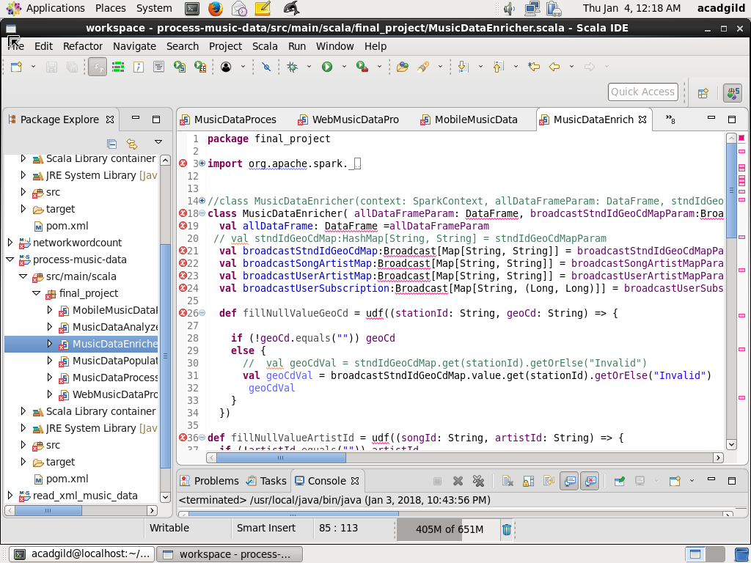

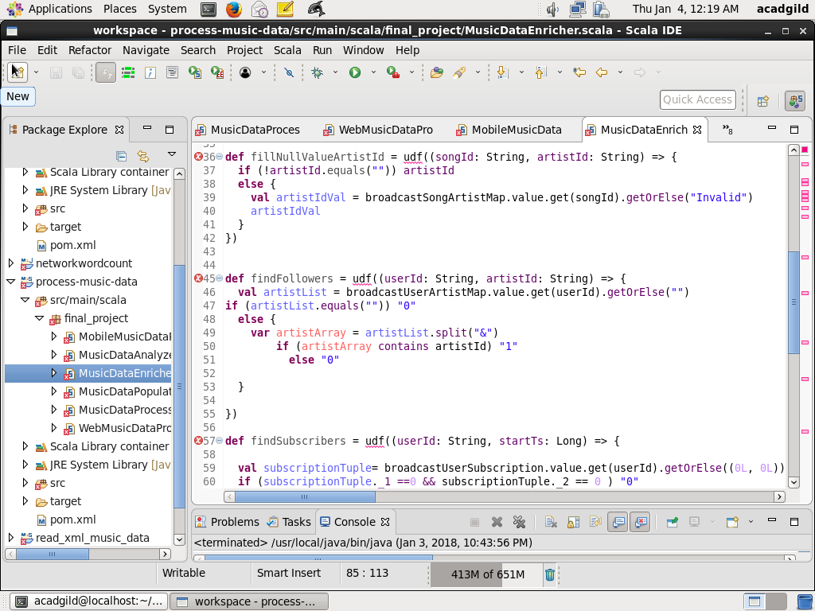

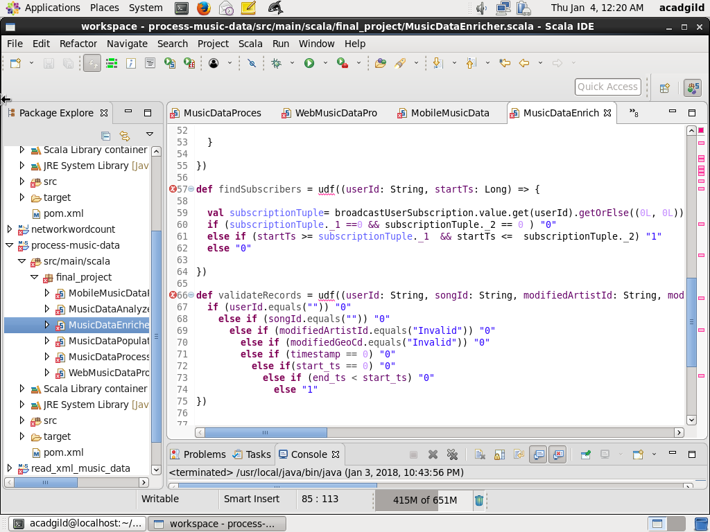

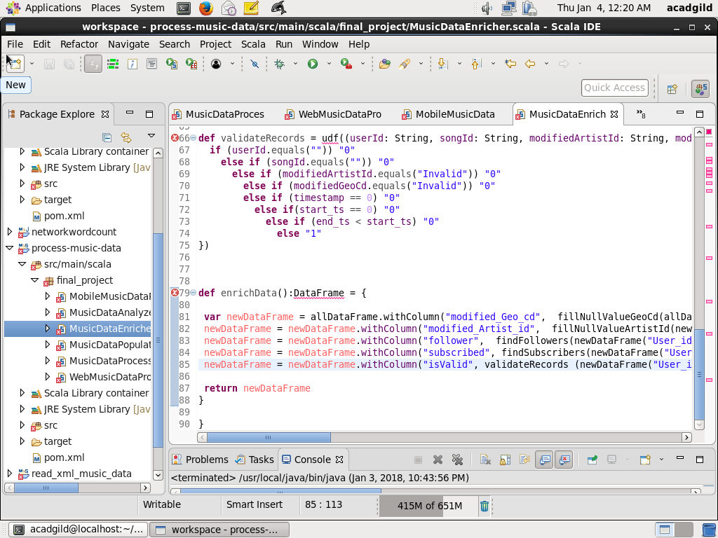

**MODULE4: Analyze the data**

* Analyze the data using defining MusicDataAnalyzer class, which will execute sql queries and the result will be stored as reports in HDFS

// Define the package final_project and import all the dependent packages

package final_project

import org.apache.log4j.{ Level, LogManager, PropertyConfigurator }

import org.apache.spark.sql.AnalysisException

import org.apache.spark._

import org.apache.spark.sql.SQLContext

import org.apache.spark.sql.DataFrame

import scala.collection.mutable.HashMap

// Define the class MusicDataAnalyzer with parameters SparkContext, SQLContext and DataFrame

class MusicDataAnalyzer(context: SparkContext, sqc: SQLContext, musicDataDFParam: DataFrame) extends Serializable {

val musicDataDF: DataFrame = musicDataDFParam

val sc = context

val sqlContext = sqc

// Define logger and reportBasePath and currentTimestamp

val log = LogManager.getRootLogger

log.setLevel(Level.INFO)

val reportBasePath = "/user/acadgild/project_music_data_analysis/reports/"

val currentTimestamp = System.currentTimeMillis().toString

// Define method analyze which will in run call all the methods for analysis

// While calling method, each one is put in try catch block so that failing one does not impact others

def analyze() = {

import sqlContext.implicits._

// Define temporary table MusicDataDetailed on the dataframe

musicDataDF.registerTempTable("MusicDataDetailed")

log.info("Before calling getAllRecords()")

try {

getAllRecords()

} catch {

case e: Exception => log.error("Exception got while calling getAllRecords: " + e)

}

log.info("Before calling getTop10Stations()")

try {

getTop10Stations()

} catch {

case e: Exception => log.error("Exception got while calling getTop10Stations: " + e)

}

log.info("Before calling getMusicDurtionByUser()")

try {

getMusicDurtionByUserType()

} catch {

case e: Exception => log.error("Exception got while calling getTop10Stations: " + e)

}

log.info("Before calling getTo10ConnectedArtists()")

try {

getTop10ConnectedArtists()

} catch {

case e: Exception => log.error("Exception got while calling getTop10ConnectedArtists: " + e)

}

log.info("Before calling getTop10UnsubscribedUsers()")

try {

getTop10UnsubscribedUsers()

} catch {

case e: Exception => log.error("Exception got while calling getTop10UnsubscribedUsers(): " + e)

}

log.info("Before calling getTo10SongsHavignMaximumRevenue()")

try {

getTop10SongsHavingMaximumRevenue()

} catch {

case e: Exception => log.error("Exception got while calling getTop10SongsHavingMaximumRevenue(): " + e)

}

}

// Method getAllRecords will select all the records from MusicDataDetailed

def getAllRecords() {

log.info(" Get All records")

// Run the query to get the result

val df = sqlContext.sql("SELECT * FROM MusicDataDetailed ")

df.show()

// Store the result as a single file in HDFS with reportPath and report name MusicDataAllRecords concatenated with current timestamp

val df1 = df.repartition(1)

df1.write.format("com.databricks.spark.csv").option("header", "true").save(reportBasePath + "/MusicDataAllRecords_" + currentTimestamp)

}

// The method getTop10Stations will return top 10 stations were maximum songs are played which are

// liked by unique user

def getTop10Stations() {

log.info(" Top 10 Music Stations where maximum numbers of songs played which are liked by unique users")

// Execute query to get Station_id User_id and count of music played Group by Station_id, User_id and // Likes is 1 and isValid is 1

sqlContext.sql("SELECT Station_id, User_id, count(*) AS music_count FROM MusicDataDetailed "

+ " WHERE Likes='1' AND isValid='1' GROUP BY Station_id, User_id")

.registerTempTable("MusicCountByStation")

// Execute query to get unique unique count for user liked, so music_count is greater than 1, it is

// considered 1

sqlContext.sql("SELECT Station_id, User_id, CASE WHEN music_count> 1 THEN 1 ELSE music_count END "

+ " AS unique_music_count FROM MusicCountByStation")

.registerTempTable("UniqueMusicCountByStation")

// Using sum method of SQL, aggregate the total music count group by Station_id and order

// total_music_count desceding. Take first 10 records

val df = sqlContext.sql("SELECT Station_id, sum(unique_music_count) AS total_music_count "

+ " FROM UniqueMusicCountByStation GROUP BY Station_id ORDER BY total_music_count "

+ " DESC LIMIT 10 ")

df.show()

// Store the query output to HDFS as a csv report Top10Stations concatenated with timestamp in

// reportBasePath

val df1 = df.repartition(1)

df1.write.format("com.databricks.spark.csv").option("header", "true").save(reportBasePath + "/Top10Stations_" + currentTimestamp)

}

// The method getMusicDurtionByUserType returns total lke music by each category of user Subscribed

// or Unsubscribed

def getMusicDurtionByUserType() {

log.info(" Total duration of Songs played by Subscibed and Unsubsribed Users")

sqlContext.sql("SELECT CASE WHEN subscribed='1' THEN 'Subscribed' ELSE 'Unsubscribed' END AS User_type, (End_ts -Start_ts) AS duration "

+ " FROM MusicDataDetailed WHERE isValid='1'")

.registerTempTable("UserTypeDuration")

val df = sqlContext.sql("SELECT User_type, SUM(duration) AS total_duration_milliseconds FROM UserTypeDuration "

+ " GROUP BY User_type ORDER BY total_duration_milliseconds DESC")

df.show()

val df1 = df.repartition(1)

df1.write.format("com.databricks.spark.csv").option("header", "true").save(reportBasePath + "/MusicDurationByUserType_" + currentTimestamp)

}

// The method getTop10ConnectedArtists return top 10 connected artists who are followed by user

def getTop10ConnectedArtists() {

log.info(" Top 10 Connected Artists")

sqlContext.sql("SELECT Artist_id, User_id, count(*) AS music_count FROM MusicDataDetailed "

+ " WHERE follower='1' AND isValid='1' GROUP BY Artist_id, User_id")

.registerTempTable("MusicCountByArtist")

sqlContext.sql("SELECT Artist_id, User_id, CASE WHEN music_count> 1 THEN 1 ELSE music_count END "

+ " AS unique_music_count FROM MusicCountByArtist")

.registerTempTable("UniqueMusicCountByUser")

val df = sqlContext.sql("SELECT Artist_id, sum(unique_music_count) AS total_music_count "

+ " FROM UniqueMusicCountByUser GROUP BY Artist_id ORDER BY total_music_count "

+ " DESC LIMIT 10 ")

df.show()

val df1 = df.repartition(1)

df1.write.format("com.databricks.spark.csv").option("header", "true").save(reportBasePath + "/Top10ConnectedArtists_" + currentTimestamp)

}

// The method getTop10SongsHavingMaximumRevenue returns top 10 songs having maximum royalty r

//revenue

def getTop10SongsHavingMaximumRevenue() {

log.info(" Top 10 Songs Having maximum revenue")

sqlContext.sql("SELECT Songs_id, CASE WHEN End_ts is NOT NULL AND Start_ts is NOT NULL and End_ts > Start_ts THEN End_ts - Start_ts ELSE 0 END AS duration FROM MusicDataDetailed "

+ " WHERE (Likes='1' OR Song_end_type = '0') AND isValid='1' ")

.registerTempTable("SongDuration")

val df = sqlContext.sql("SELECT Songs_id, SUM(duration) AS total_duration_milliseconds FROM SongDuration "

+ " GROUP BY Songs_id ORDER BY total_duration_milliseconds DESC LIMIT 10")

df.show()

val df1 = df.repartition(1)

df1.write.format("com.databricks.spark.csv").option("header", "true").save(reportBasePath + "/Top10SongsHavignMaximumRevenue_" + currentTimestamp)

}

// The method getTop10UnsubscribedUsers will retrun top 10 unsubscribed users

def getTop10UnsubscribedUsers() {

log.info(" Top 10 Unsubscribed Users")

sqlContext.sql("SELECT User_id,CASE WHEN End_ts is NOT NULL AND Start_ts is NOT NULL and End_ts > Start_ts THEN End_ts - Start_ts ELSE 0 END AS duration FROM MusicDataDetailed "

+ " WHERE subscribed='0' AND isValid='1'")

.registerTempTable("SongDuration")

val df = sqlContext.sql("SELECT User_id, SUM(duration) AS total_duration_milliseconds FROM SongDuration "

+ " GROUP BY User_id ORDER BY total_duration_milliseconds DESC LIMIT 10")

df.show()

val df1 = df.repartition(1)

df1.write.format("com.databricks.spark.csv").option("header", "true").save(reportBasePath + "/Top10UnsubscribedUsers_" + currentTimestamp)

}

}

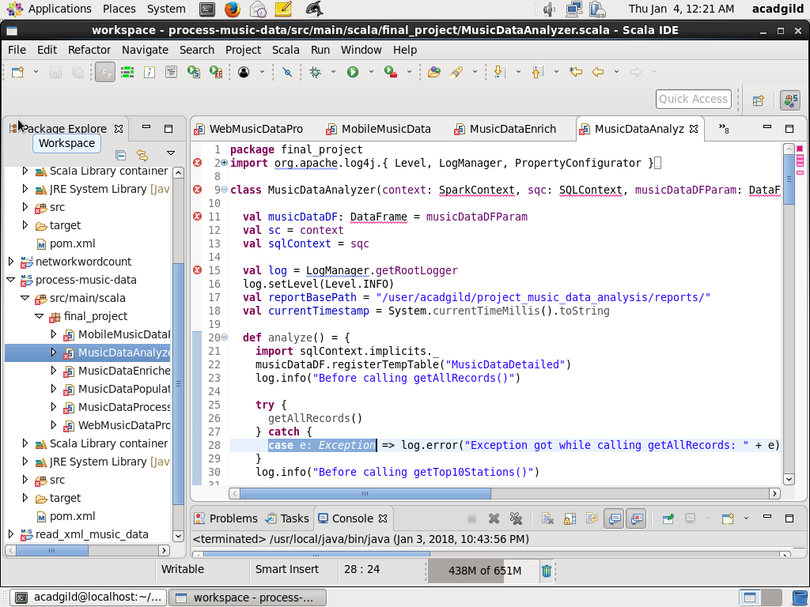

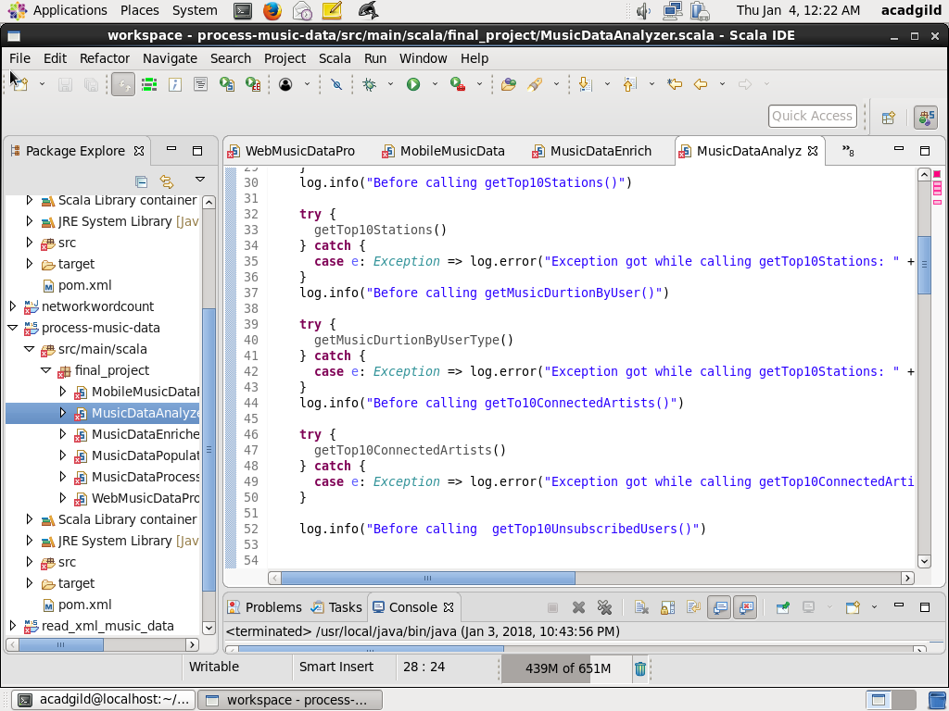

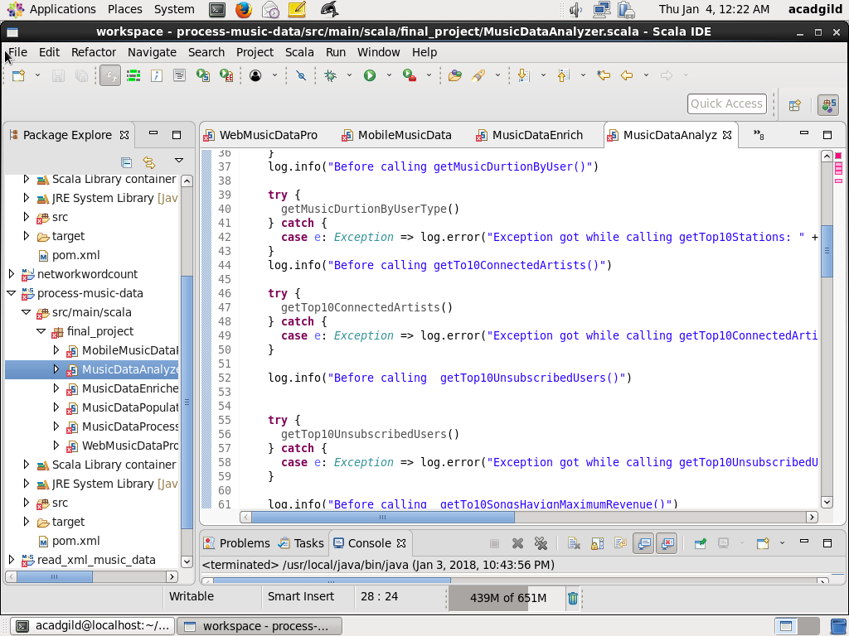

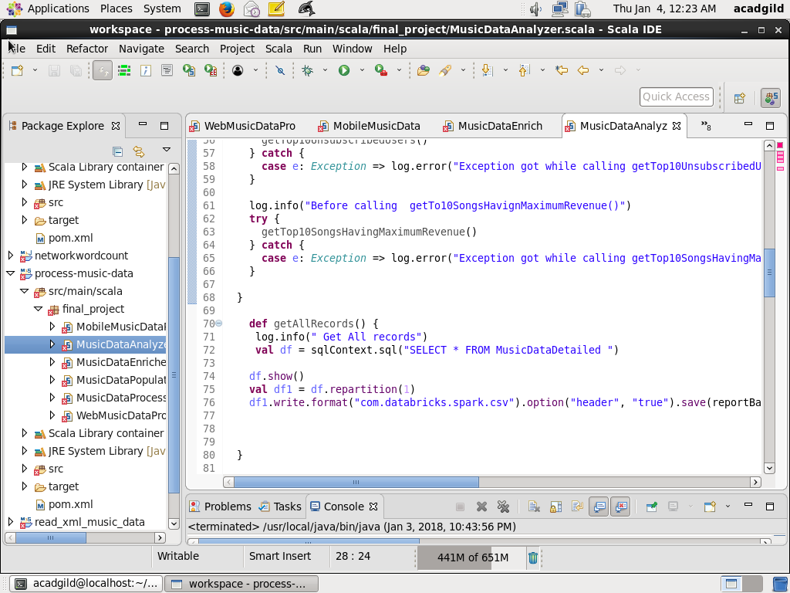

**Module5: MusicDataPopulateMapFromLookupTables : Load the maps from HBase tables**

To load the HBase table, I used the class MusicDataPopulateMapFromLookupTables

// Import the dependent packages

package final_project

import org.apache.spark._

import org.apache.spark.sql.SQLContext

import org.apache.hadoop.hbase.util.Bytes

import org.apache.hadoop.hbase.client.{Put,HTable}

import org.apache.hadoop.hbase.HBaseConfiguration

import org.apache.hadoop.hbase.HTableDescriptor

import org.apache.hadoop.hbase.HColumnDescriptor

import org.apache.hadoop.hbase.client.HBaseAdmin

import org.apache.hadoop.hbase.client.HTable

import org.apache.hadoop.hbase.mapreduce.TableInputFormat

import org.apache.log4j.{ Level, LogManager, PropertyConfigurator }

// Create class MusicDataPopulateMapFromLookupTables with parameters

class MusicDataPopulateMapFromLookupTables(context: SparkContext) {

val sc:SparkContext = context

val hconf = HBaseConfiguration.create

val admin = new HBaseAdmin(hconf)

val log = LogManager.getRootLogger

log.setLevel(Level.INFO)

// Create map from HBase table with key and value as column value

def getCommonLookupMap(tablename:String) = {

if (!admin.isTableAvailable(tablename)) {

log.warn("HBase Table " + tablename + " does not exists")

} else {

log.info("Table " + tablename + " exists")

}

val hbaseRDD = sc.newAPIHadoopRDD(hconf, classOf[TableInputFormat], classOf[org.apache.hadoop.hbase.io.ImmutableBytesWritable], classOf[org.apache.hadoop.hbase.client.Result])

val resultRDD = hbaseRDD.map(tuple=>tuple._2)

val keyValueRDD = resultRDD.map(result => (Bytes.toString(result.getRow()).split(" ")(0), Bytes.toString(result.value)))

val map = keyValueRDD.collectAsMap

scala.collection.immutable.Map(map.toSeq:_*)

}

// Populate Map with key StationId and GeoCd from table StndIdGeoCd

def getStationIdGeoCdMap() = {

val tablename = "StndIdGeoCd"

hconf.set(TableInputFormat.INPUT_TABLE, tablename)

getCommonLookupMap(tablename)

}

// Populate Map with key songId and Artist from table SongArtist

def getSongArtistMap() = {

val tablename = "SongArtist"

hconf.set(TableInputFormat.INPUT_TABLE, tablename)

getCommonLookupMap(tablename)

}

// Populate Map with key userId and Artist List from table UserArtist

def getUserArtistMap() = {

val tablename = "UserArtist"

hconf.set(TableInputFormat.INPUT_TABLE, tablename)

getCommonLookupMap(tablename)

}

// Populate map with Key as UserId and Value as tuple (start_ts, end_ts)

def getUserSubscriptionMap():scala.collection.immutable.Map[String, (Long, Long)] = {

val tablename = "UserSubscription"

hconf.set(TableInputFormat.INPUT_TABLE, tablename)

if (!admin.isTableAvailable(tablename)) {

log.warn("HBase Table " + tablename + " does not exists")

} else {

log.info("Table " + tablename + " exists")

}

val hbaseRDD = sc.newAPIHadoopRDD(hconf, classOf[TableInputFormat], classOf[org.apache.hadoop.hbase.io.ImmutableBytesWritable], classOf[org.apache.hadoop.hbase.client.Result])

val resultRDD = hbaseRDD.map(tuple=>tuple._2)

val keyValueRDD = resultRDD.map(result => (Bytes.toString(result.getRow()).split(" ")(0), (

if (Bytes.toString(result.getValue(new String("Subscription").getBytes(), new String("Start_ts").getBytes)).equals("")) 0 else Bytes.toString(result.getValue(new String("Subscription").getBytes(), new String("Start_ts").getBytes)).toLong,

if (Bytes.toString(result.getValue(new String("Subscription").getBytes(), new String("End_ts").getBytes)).equals("")) 0 else Bytes.toString(result.getValue(new String("Subscription").getBytes(), new String("End_ts").getBytes)).toLong

)))

val map = keyValueRDD.collectAsMap

return scala.collection.immutable.Map(map.toSeq:_*)

}

}

Screenshot is as below:

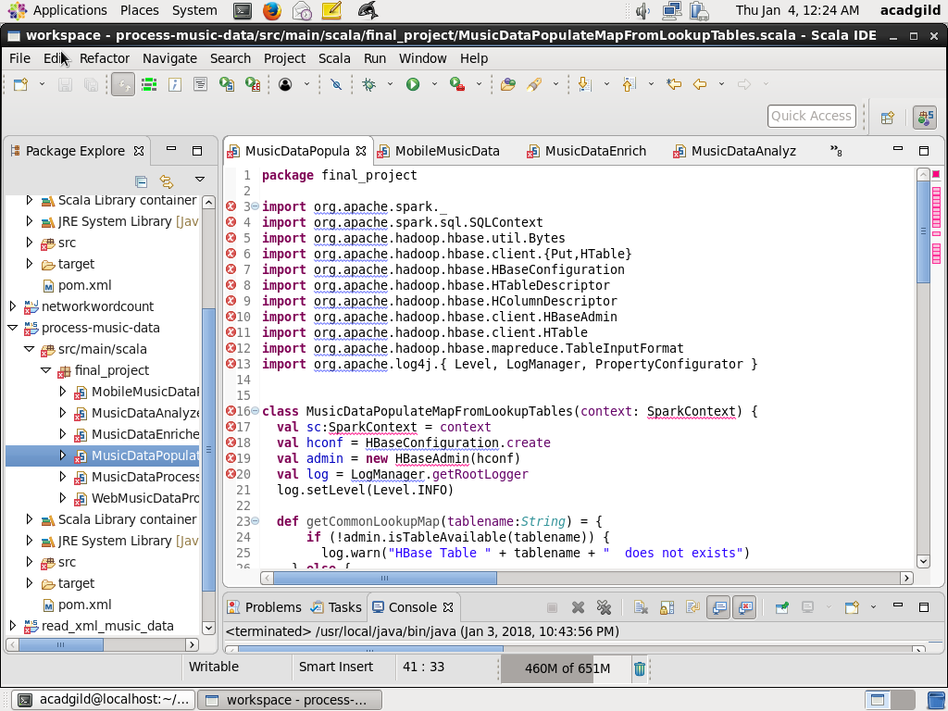

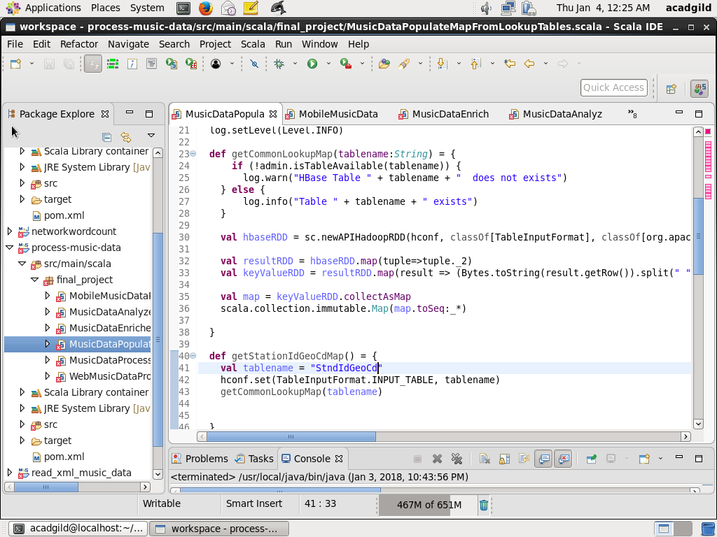

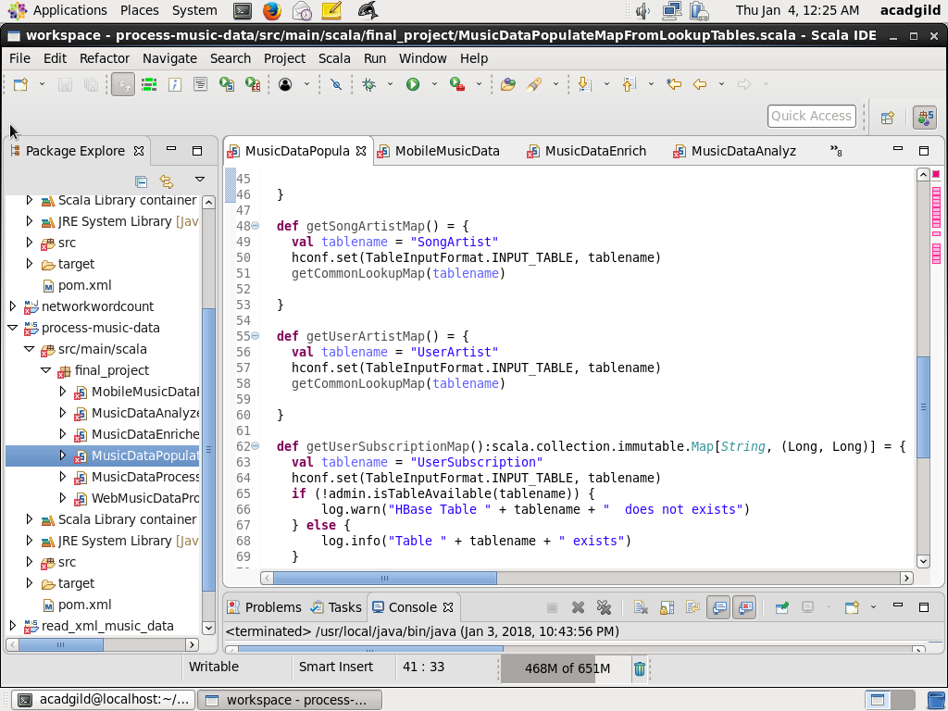

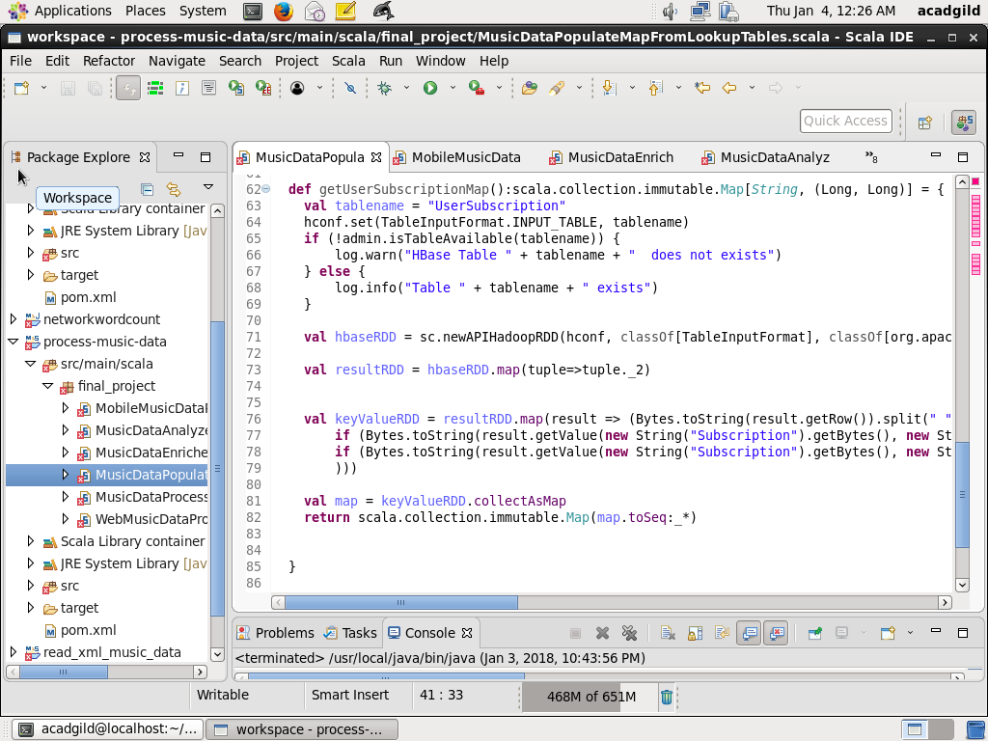

**MODULE6: Main object MusicDataProcessorApp**

// Import all the dependent packages

package final_project

import org.apache.log4j.{ Level, LogManager, PropertyConfigurator }

import org.apache.spark._

import org.apache.spark.sql.SQLContext

import org.apache.spark.sql.DataFrame

import scala.collection.mutable.HashMap

// define object MusicDataProcessorApp

object MusicDataProcessorApp {

// define method main

def main(args: Array[String]) {

val web_file_path = "/data/web/file-1.xml"

val mobile_file_path = "file:///data/mob/file.txt"

val log = LogManager.getRootLogger

log.setLevel(Level.INFO)

// Define all the contexts

val conf = new SparkConf().setAppName("MusicDataProcessApp").setMaster("local[2]")

val sc = new SparkContext(conf)

val sqlContext = new SQLContext(sc)

import sqlContext.implicits._

sc.setLogLevel("ERROR")

// Populate the map from StationId GeoCd and create a broadcast object

val populateMusicDataMap = new MusicDataPopulateMapFromLookupTables(sc)

val stndIdGeoCdMap:Map[String, String] = populateMusicDataMap.getStationIdGeoCdMap()

val broadcastStndIdGeoCdMap = sc.broadcast(stndIdGeoCdMap)

// Populate the map songArtistMap from songId Aritist and create a broadcast object

val songArtistMap = populateMusicDataMap.getSongArtistMap()

val broadcastSongArtistMap = sc.broadcast(songArtistMap)

// Populate the map userArtistMap from userId and Aritist and create a broadcast object

val userArtistMap = populateMusicDataMap.getUserArtistMap()

val broadcastUserArtistMap = sc.broadcast(userArtistMap)

// Populate the map userSubscription from userId and subscription tuple (start_ts, end_ts) and

// create a broadcast object

val userSubscription:Map[String, (Long, Long)] = populateMusicDataMap.getUserSubscriptionMap()

val broadcastuserSubscription = sc.broadcast(userSubscription)

// Call the processData method on WebMusicDataProcessor and get the dataframe webDataFrame

val webMusicDataProcessor = new WebMusicDataProcessor(web_file_path, sc, sqlContext )

log.info("Before calling webMusicDataProcessor.processData()")

val webDataFrame:DataFrame = webMusicDataProcessor.processData()

log.info("After calling webMusicDataProcessor.processData()")

// Call the processData method on MobileMusicDataProcessor and get the dataframe mobileDataFrame

val mobileMusicDataProcessor = new MobileMusicDataProcessor(mobile_file_path, sc, sqlContext)

log.info("Before calling mobileMusicDataProcessor.processData()")

val mobileDataFrame:DataFrame = mobileMusicDataProcessor.processData()

log.info("After calling webMusicDataProcessor.processData()")

// Combine webDataFrame and mobileDataFrame into one allDataFrame

val allDataFrame:DataFrame = webDataFrame.unionAll(mobileDataFrame)

log.info("allDataFrame count =" + allDataFrame.count)

// Call the enrichData method on MusicDataEnricher and enhance the data

val musicDataEnricher = new MusicDataEnricher(allDataFrame, broadcastStndIdGeoCdMap, broadcastSongArtistMap, broadcastUserArtistMap, broadcastuserSubscription)

val enrichedAllDataFrame:DataFrame = musicDataEnricher.enrichData()

log.info("Showing dataframe after enrichment")

enrichedAllDataFrame.show(100)

enrichedAllDataFrame.registerTempTable("DetailedMusicData")

// Call the analyze method on musicDataAnalyzer

val musicDataAnalyzer = new MusicDataAnalyzer(sc, sqlContext, enrichedAllDataFrame)

musicDataAnalyzer.analyze()

}

}

**COMPILATION:** pom.xml file is as below:

<project xmlns="http://maven.apache.org/POM/4.0.0" xmlns:xsi="http://www.w3.org/2001/XMLSchema-instance" xsi:schemaLocation="http://maven.apache.org/POM/4.0.0 http://maven.apache.org/xsd/maven-4.0.0.xsd">

<modelVersion>4.0.0</modelVersion>

<groupId>final_project</groupId>

<artifactId>process_music_data</artifactId>

<version>0.0.1-SNAPSHOT</version>

<properties>

<maven.compiler.source>1.8</maven.compiler.source>

<maven.compiler.target>1.8</maven.compiler.target>

<encoding>UTF-8</encoding>

<scala.version>2.10.5</scala.version>

</properties>

<build>

<sourceDirectory>src/main/scala</sourceDirectory>

<resources>

<resource>

<directory>src/main/scala</directory>

<excludes>

<exclude>**/*.java</exclude>

</excludes>

</resource>

</resources>

<plugins>

<plugin>

<artifactId>maven-compiler-plugin</artifactId>

<version>3.5.1</version>

<configuration>

<source>1.8</source>

<target>1.8</target>

</configuration>

</plugin>

<plugin>

<groupId>org.scala-tools</groupId>

<artifactId>maven-scala-plugin</artifactId>

<version>2.15.2</version>

<executions>

<execution>

<goals>

<goal>compile</goal>

</goals>

</execution>

</executions>

</plugin>

</plugins>

</build>

<dependencies>

<!-- https://mvnrepository.com/artifact/org.apache.spark/spark-core_2.11 -->

<dependency>

<groupId>org.apache.spark</groupId>

<artifactId>spark-core_2.10</artifactId>

<version>1.6.0</version>

</dependency>

<!-- https://mvnrepository.com/artifact/org.apache.spark/spark-sql_2.11 -->

<dependency>

<groupId>org.apache.spark</groupId>

<artifactId>spark-sql_2.10</artifactId>

<version>1.6.0</version>

</dependency>

<dependency>

<groupId>org.apache.spark</groupId>

<artifactId>spark-hive_2.10</artifactId>

<version>1.6.0</version>

<scope>provided</scope>

</dependency>

<!-- https://mvnrepository.com/artifact/org.apache.hbase/hbase-client -->

<dependency>

<groupId>org.apache.hbase</groupId>

<artifactId>hbase-client</artifactId>

<version>0.98.14-hadoop2</version>

</dependency>

<!-- https://mvnrepository.com/artifact/org.apache.hbase/hbase-common -->

<dependency>

<groupId>org.apache.hbase</groupId>

<artifactId>hbase-common</artifactId>

<version>0.98.14-hadoop2</version>

</dependency>

<!-- https://mvnrepository.com/artifact/org.apache.hbase/hbase-protocol -->

<dependency>

<groupId>org.apache.hbase</groupId>

<artifactId>hbase-protocol</artifactId>

<version>0.98.14-hadoop2</version>

</dependency>

<!-- https://mvnrepository.com/artifact/org.apache.hbase/hbase-hadoop2-compat -->

<dependency>

<groupId>org.apache.hbase</groupId>

<artifactId>hbase-hadoop2-compat</artifactId>

<version>0.98.14-hadoop2</version>

</dependency>

<!-- https://mvnrepository.com/artifact/org.apache.hbase/hbase-annotations -->

<dependency>

<groupId>org.apache.hbase</groupId>

<artifactId>hbase-annotations</artifactId>

<version>0.98.14-hadoop2</version>

</dependency>

<!-- https://mvnrepository.com/artifact/org.apache.hbase/hbase-server -->

<dependency>

<groupId>org.apache.hbase</groupId>

<artifactId>hbase-server</artifactId>

<version>0.98.14-hadoop2</version>

</dependency>

</dependencies>

</project>

Compilation using Run -> Maven Install, screenshot is as below:

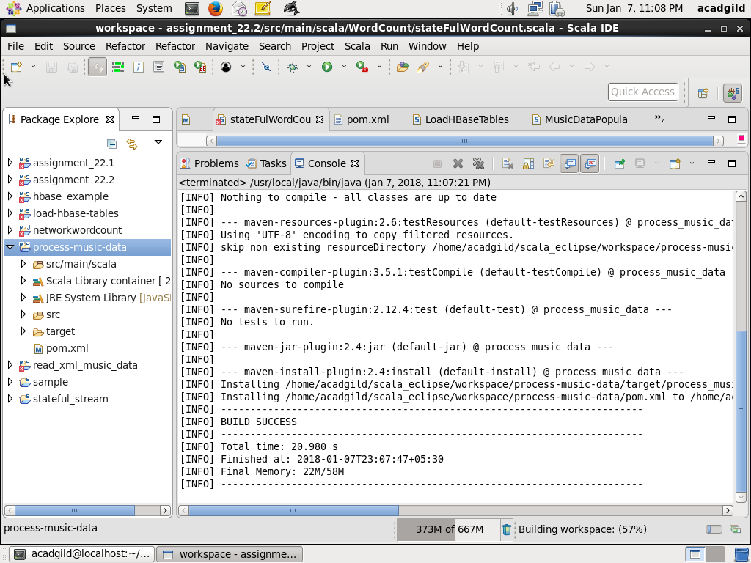

**OUTPUT**:

All the folders are in HDFS are as below:

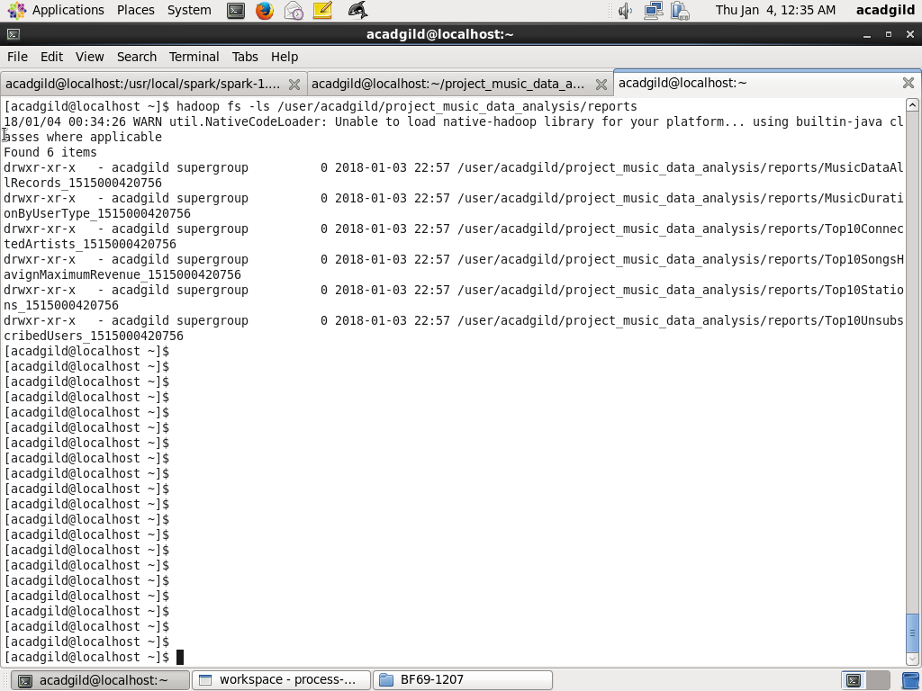

**All Records** – This will contain all the records in MusicDataDetailed

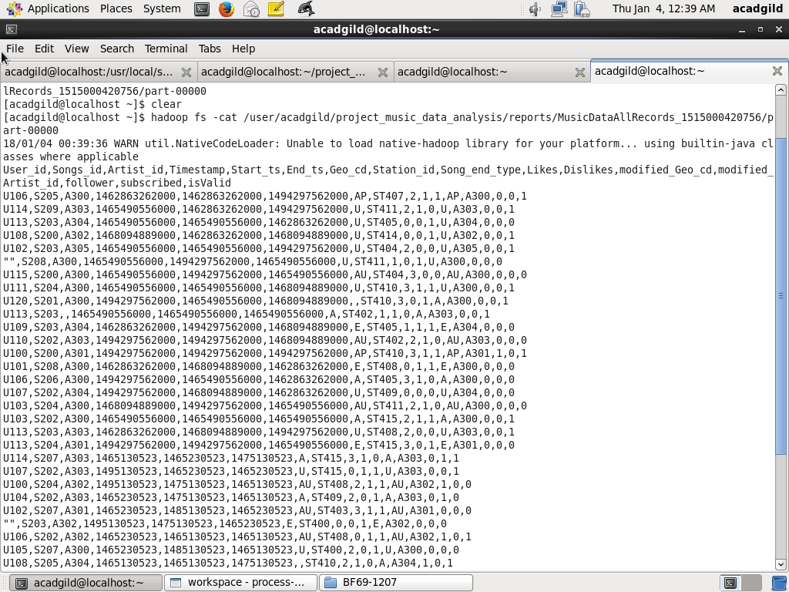

**Top10Stations** – This will top 10 stations having maximum music played which are liked by unique users

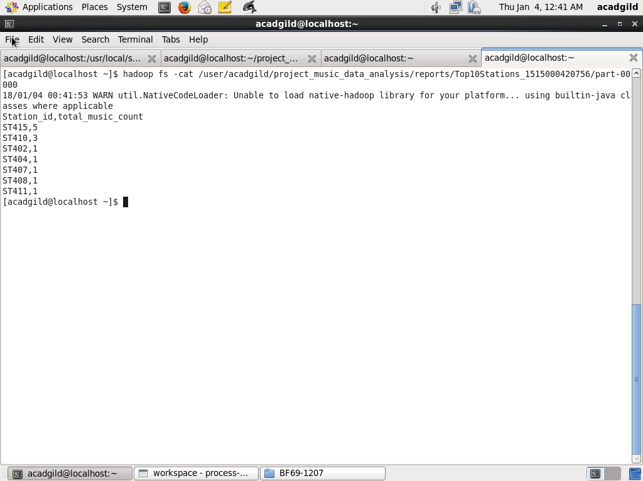

**DurationByCategory** – This will report total duration of music played by each time of user (unsubscribed/unsubscribed)

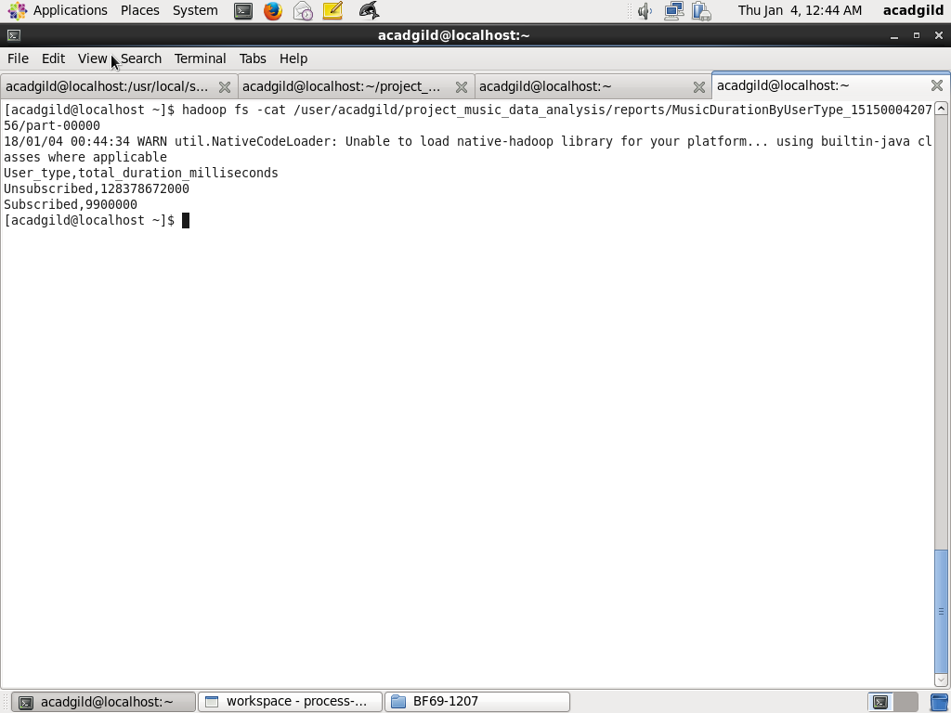

**DurationByCategory** – This will report total duration of music played by each time of user (unsubscribed/unsubscribed)



**Top10ConnectedArtists :** Top 10 Connected Artists

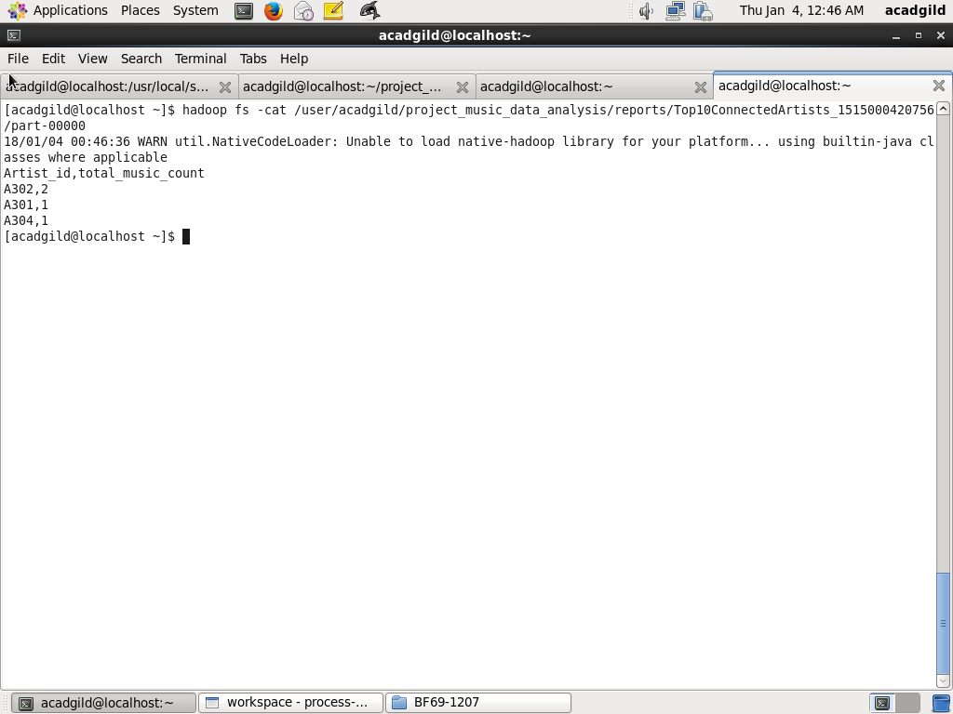

**Top10SongsHavingMaximumRevenue:** Top 10 songs have maximum revenue

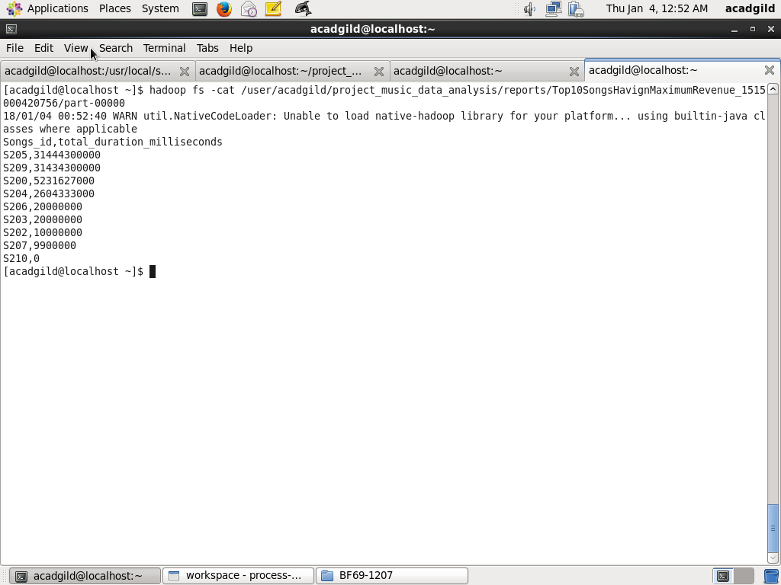



**Top10UnsubscribedUsers –** Top 10 unsubscribed users who listened to the music for maximum duration

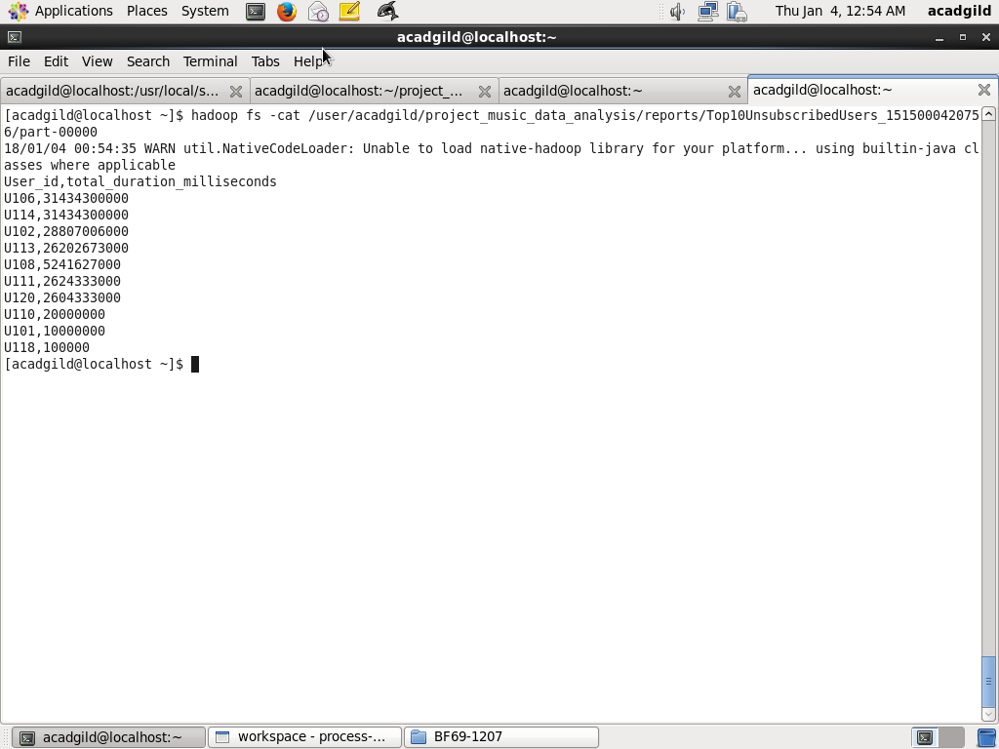

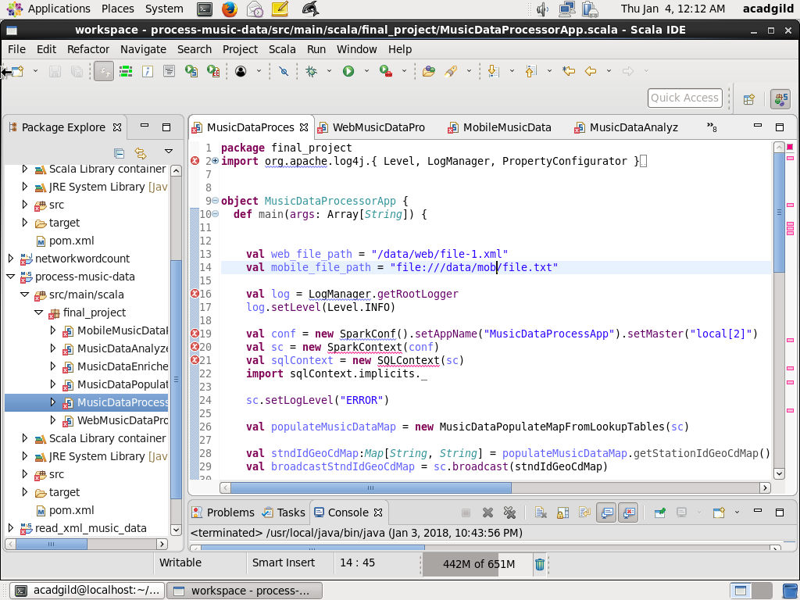

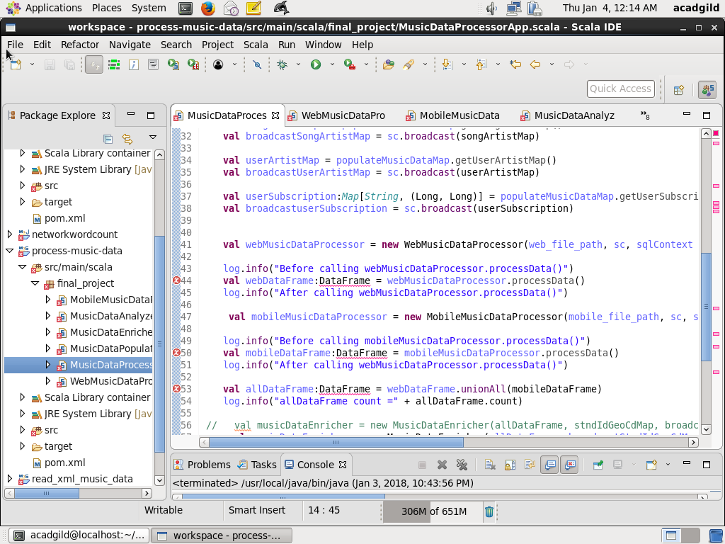

**Module7: Script for running the Music Data App**

A bash script music_data_spark_app.sh is created and it content is as below:

#!/bin/bash

export HBASE_PATH=`/usr/local/hbase/bin/hbase classpath`

cd $SPARK_HOME

echo "Starting the Music Data Application"

bin/spark-submit --class final_project.MusicDataProcessorApp --driver-class-path $HBASE_PATH --master local[2] --packages com.databricks:spark-csv_2.10:1.4.0 ~/scala_eclipse/workspace/process-music-data/target/process_music_data-0.0.1-SNAPSHOT.jar > output.log 2>&1

echo "Completed the Music Data Application"

Screenshot is as below:

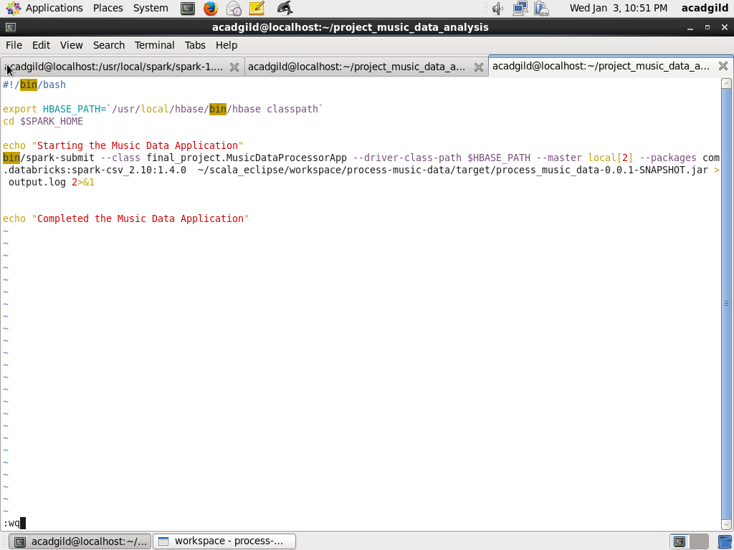

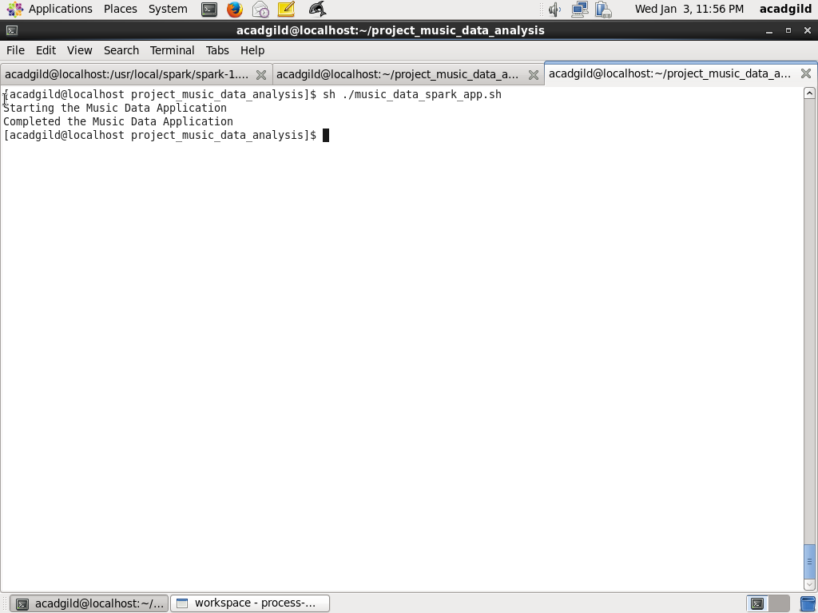

Next, a cron job is created using “crontab –e” so that the script is run every 3 hours

Content is as below

0 */4 * * * /home/acadgild/project_music_data_analysis/music_data_spark_app.sh

The screenshot is as below:

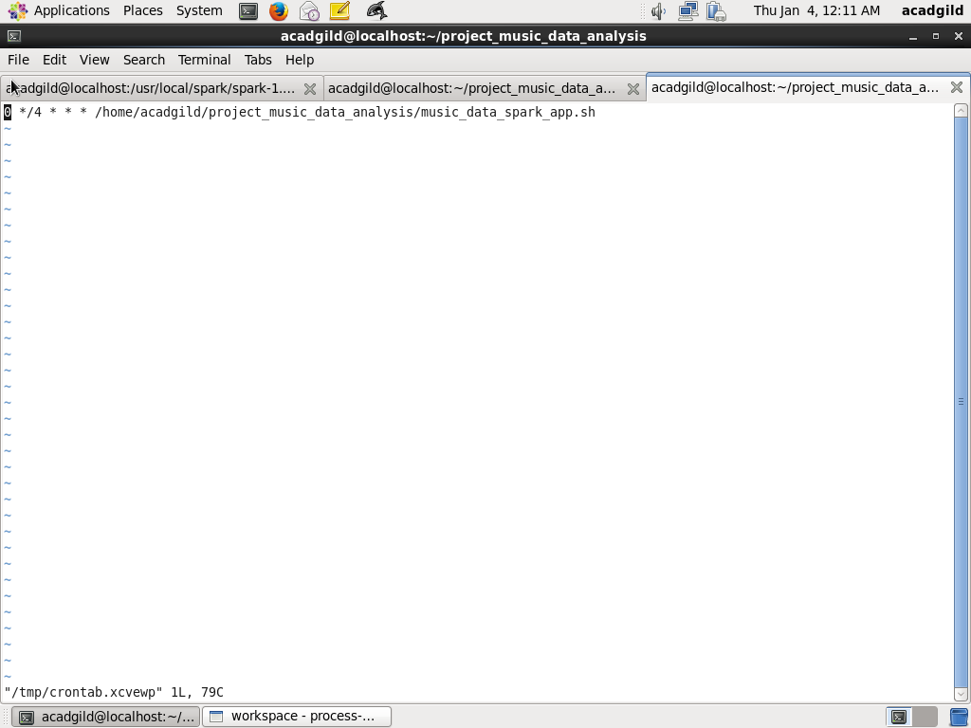

1. **Highlights of the project**
2. No join of query is used while analysiss. Data is already enriched with new fields and using broadcast maps on Lookup tables so as to avoid any join
3. Logger has been used in all over the code to allow
4. **Issues Faced and how to resolve it**

While doing project, I face following issues and how I resolved it

1. XML processing – I found the databricks provides he XML processing APIs in spark. But it was not working. The main issue I face

 I was trying the process the xml dataset (file-1.xml) to covert to spark dataframe as given for the final project. I have created a scala Object ReadXMLMusicData.scala based on the steps given in

<https://github.com/databricks/spark-xml>

Created maven project with pom.xml attached. Using mvn install, I am able to generate jar file read_xml_music_data-0.0.1-SNAPSHOT.jar . However when I try to deploy to spark using spark-submit on Acadgild VM

bin/spark-submit --class ReadXMLMusicData --master local[2] --driver-class-path /home/acadgild/.m2/repository/com/databricks/spark-xml_2.10/0.4.1/spark-xml_2.11-0.4.1.jar   ~/scala_eclipse/workspace/read_xml_music_data/target/read_xml_music_data-0.0.1-SNAPSHOT.jar

Exception in thread "main" java.lang.NoSuchMethodError: org.apache.spark.sql.DataFrameReader.load(Ljava/lang/String;)Lorg/apache/spark/sql/Dataset;  
    at ReadXMLMusicData$.main(ReadXMLMusicData.scala:12)  
    at ReadXMLMusicData.main(ReadXMLMusicData.scala)  
    at sun.reflect.NativeMethodAccessorImpl.invoke0(Native Method)  
    at sun.reflect.NativeMethodAccessorImpl.invoke(NativeMethodAccessorImpl.java:62)  
    at sun.reflect.DelegatingMethodAccessorImpl.invoke(DelegatingMethodAccessorImpl.java:43)  
    at java.lang.reflect.Method.invoke(Method.java:497)  
    at org.apache.spark.deploy.SparkSubmit$.org$apache$spark$deploy$SparkSubmit$$runMain(SparkSubmit.scala:731)  
    at org.apache.spark.deploy.SparkSubmit$.doRunMain$1(SparkSubmit.scala:181)  
    at org.apache.spark.deploy.SparkSubmit$.submit(SparkSubmit.scala:206)  
    at org.apache.spark.deploy.SparkSubmit$.main(SparkSubmit.scala:121)  
    at org.apache.spark.deploy.SparkSubmit.main(SparkSubmit.scala)

I tried  all the options

1. --packages com.databricks:spark-xml_2.10:0.4.1

2. --packages com.databricks:spark-xml_2.11:0.4.1

3. --driver-class-path /home/acadgild/.m2/repository/com/databricks/spark-xml_2.10/0.4.1/spark-xml_2.10-0.4.1.jar

4. --driver-class-path /home/acadgild/.m2/repository/com/databricks/spark-xml_2.10/0.4.1/spark-xml_2.11-0.4.1.jar

Acadgild gave the following solution:

DataFrame() was supplanted in Spark 2 by Dataset(). You'll need to import org.apache.spark.sql.Dataset and use that if you're running a Spark 1.6 client with a Spark 2.1 server-side. it would be a lot better off using at least Spark 2.1.+ dependencies.

Follow the below link to download newer version of spark.

[Spark_Download](https://spark.apache.org/downloads.html)

But I solved this I used a xml APIs from scala.xml.XML. Relevant links are as below:

https://alvinalexander.com/scala/how-to-extract-data-from-xml-nodes-in-scala

https://hadoopist.wordpress.com/2016/01/08/parsing-a-basic-xml-using-hadoop-and-spark-core-apis/

http://www.scala-lang.org/api/2.11.1/scala-xml

1. Task Not Serializable Exception:

I am encoutering "org.apache.spark.SparkException: Task Not Serializable"  In the code below when Artist_id is blank I try to get it using Song_Id from broadcastSongArtistMap.  The dataset used is the mobile dataset. Basically exception is thrown in the line below:

if (x(2).equals("")) broadcastSongArtistMap.value.get(x(1)).getOrElse("Invalid") else x(2),

The job is submitted using spark-submit. I would very much appreciate, if you can give me a solution on this ( I tied lot of things, but could not make it work)

Code snippet is as below:

val songArtistMap = Map("S200" -> "A300",  
                         "S201" -> "A301",  
                         "S202" -> "A302",  
                         "S203" -> "A303",  
                         "S204" -> "A304",  
                         "S205" -> "A301",  
                         "S206" -> "A302",  
                         "S207" -> "A303",  
                         "S208" -> "A304",  
                         "S209" -> "A305"  
                      )

val broadcastSongArtistMap = sc.broadcast(songArtistMap)   
  
case class MusicData(User_id:String, Song_id:String, Artist_id:String, Timestamp:Long,  
      Start_ts:Long, End_ts:Long, Geo_cd:String, Station_id:String, Song_end_type:String,  
      Like:String, Dislike:String)  
  
val recordRDD = sc.textFile("/home/acadgild/final_project/file.txt")  
val recordFieldsRDD = recordRDD.map(x => x.split(",")).filter(x=> x.length ==11)  
     
val recordDF = recordFieldsRDD.map(x => MusicData(x(0),  
        x(1),   
        if (x(2).equals("")) broadcastSongArtistMap.value.get(x(1)).getOrElse("Invalid") else x(2),  
        x(3).toLong,   
        x(4).toLong,  
        x(5).toLong,  
        x(6),  
        x(7),  
        x(8),  
        if (x(9).equals("")) "0" else x(9),  
        if (x(10).equals("")) "0" else x(10))).toDF

recordDF.show

Solution: The problem was that SparkContext as parameter to class MobileMusicDataProcessor was not Serializable. When I removed the SparkContext, it worked

1. Continue does not work for scala:

There is no support for continue in scala. To use it I created a case class

CustomException(message:String) extends Exception(message)

Then used

1. HBase support with Spark

I used the following link:

https://acadgild.com/blog/spark-on-hbase/

<https://acadgild.com/blog/apache-hbase-beginners-guide/>

Even using that the multiple fields were not working. To solve this, I used the following code:

val hbaseRDD = sc.newAPIHadoopRDD(hconf, classOf[TableInputFormat], classOf[org.apache.hadoop.hbase.io.ImmutableBytesWritable], classOf[org.apache.hadoop.hbase.client.Result])

val resultRDD = hbaseRDD.map(tuple=>tuple._2)

val keyValueRDD = resultRDD.map(result => (Bytes.toString(result.getRow()).split(" ")(0), (

if (Bytes.toString(result.getValue(new String("Subscription").getBytes(), new String("Start_ts").getBytes)).equals("")) 0 else Bytes.toString(result.getValue(new String("Subscription").getBytes(), new String("Start_ts").getBytes)).toLong,

if (Bytes.toString(result.getValue(new String("Subscription").getBytes(), new String("End_ts").getBytes)).equals("")) 0 else Bytes.toString(result.getValue(new String("Subscription").getBytes(), new String("End_ts").getBytes)).toLong

)))

1. Map was giving compilation error

There are two types of Map Mutable and Immutable

I needed to convert to Immutable map to make the compilation work using the following:

val map = keyValueRDD.collectAsMap

return scala.collection.immutable.Map(map.toSeq:_*)

1. toDF does not work and giving compilation error

To solve this I needed o add:

import sqlContext.implicits._

To every class

1. The following command was giving exception:

sqlContext.resisterTempTable(“MusicDataDetailed”)

The problem was not I was creating sqlContext in every class and dataframe was created tow different classes. To solve this I had to use one sqlContext created at MusicDataProcessorApp

try {

if (userId.equals("") && songId.equals("") && artistId.equals("")) {

throw CustomException("Record is blank")

} else {

recordListBuffer += ((userId, songId, artistId, timestampLong, startTsLong, endTsLong, geoCd, stationId, songEndType, like, dislike))

}

} catch {

case CustomException(msg) => msg

}

}

1. Not able to store query result to file..

To use this I used databricks csv API:

val df = sqlContext.sql("SELECT Songs_id, SUM(duration) AS total_duration_milliseconds FROM SongDuration "

+ " GROUP BY Songs_id ORDER BY total_duration_milliseconds DESC LIMIT 10")

df.show()

val df1 = df.repartition(1)

df1.write.format("com.databricks.spark.csv").option("header", "true").save(reportBasePath + "/Top10SongsHavignMaximumRevenue_" + currentTimestamp)

bin/spark-submit --class final_project.MusicDataProcessorApp --master local[2] --packages com.databricks:spark-csv_2.10:1.4.0 --driver-java-options "-Dlog4j.configuration=file:/usr/local/spark/spark-1.6.0-bin-hadoop2.6/conf/log4j.properties" ~/scala_eclipse/workspace/process-music-data/target/process_music_data-0.0.1-SNAPSHOT.jar > output.log 2>&1

1. AnalysisException whenever I used a field which does not exist because of case. For example Song_Id, but the schma it is Song_id. Even if I restart or whatever I does not work. I needed to change the schema to Songs_id to solve this